**IDEAS to gain insights**

# **Feature DEFINITION**

##### 

##### **1) Check correlation between target and book WAP realized_vol in first 10 mins. Aggregate book WAP price using the log returns and realised volatility formulas for each time id. Plot scatterplot this against the corresponding target for all time id.**

yes confirmed!

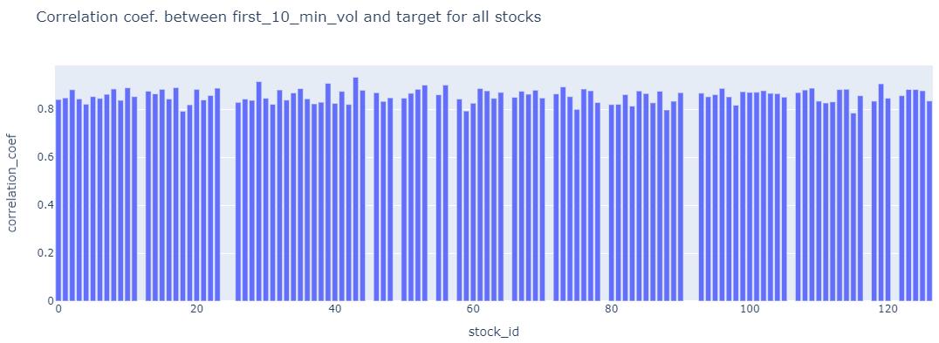

##### **2) Check correlation between**

##### **i) target (2nd 10 mins vol.) and trade execution stock price at the available times.**

Aggregate **trade execution price using the log returns and realised volatility formulas for each time id. Plot scatterplot this against the corresponding target for all time id.**

**Yes confirmed**

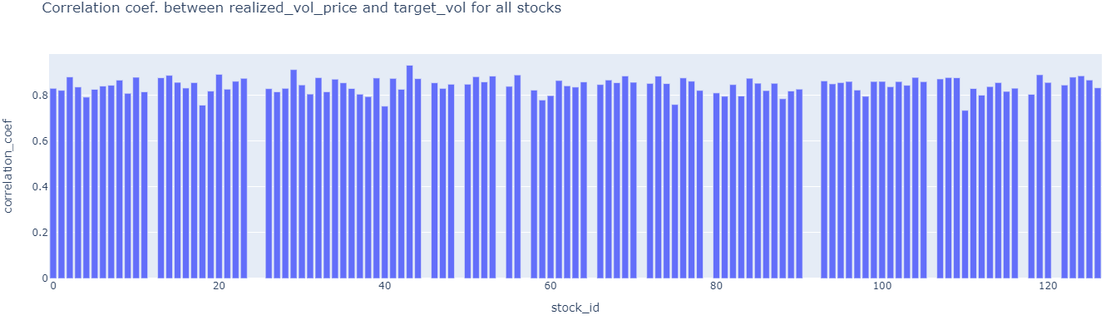

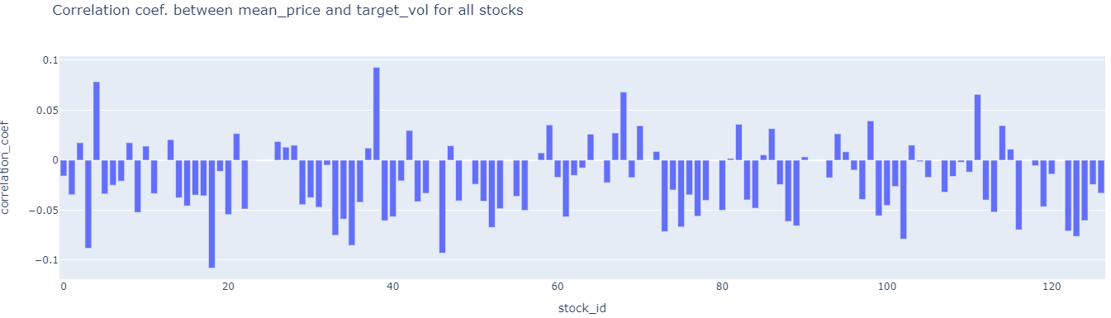

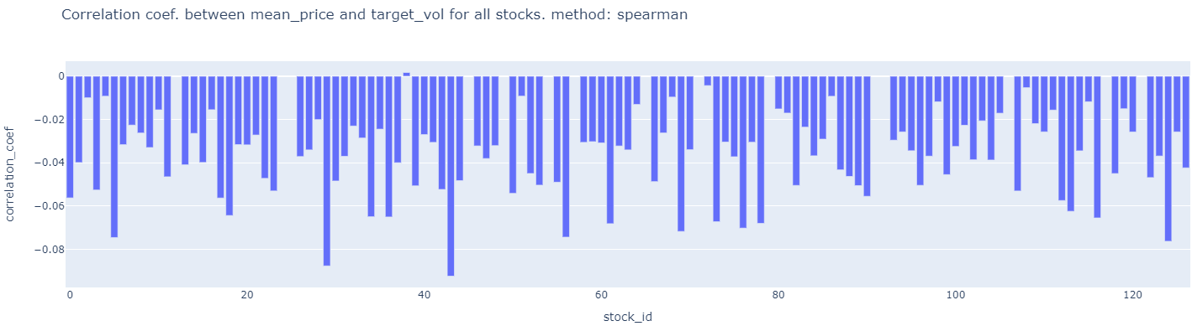

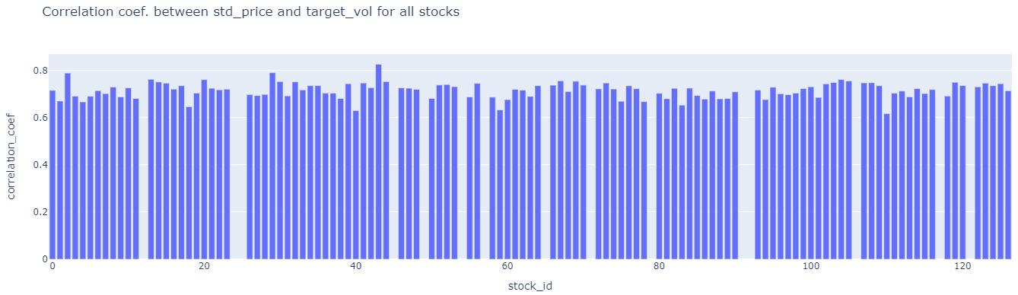

##### **ii) target (2nd 10 mins vol.) and size at the available times.**

Aggregate size by taking standard deviation or mean at each time id. **Plot scatterplot of this against the corresponding target for each time id.**

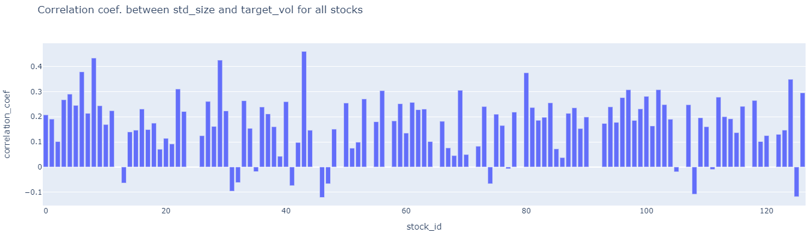

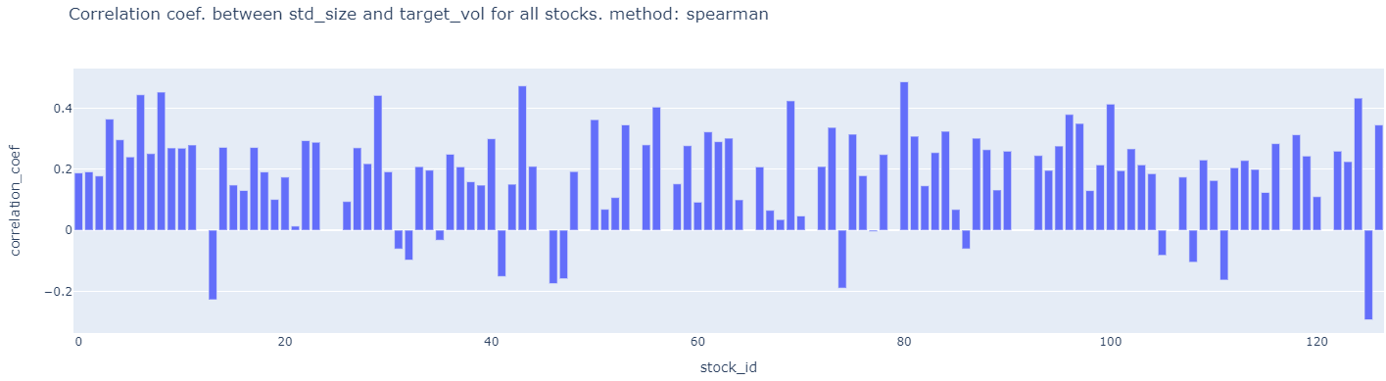

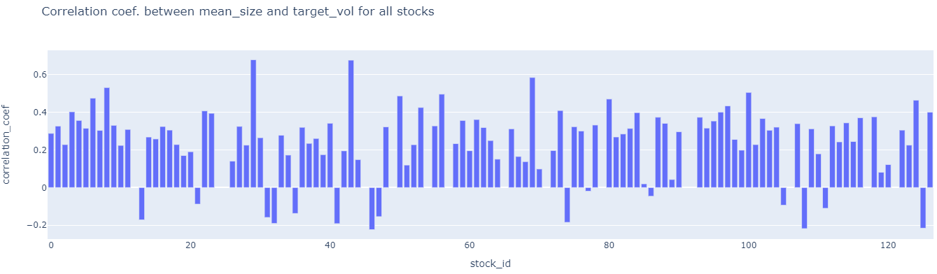

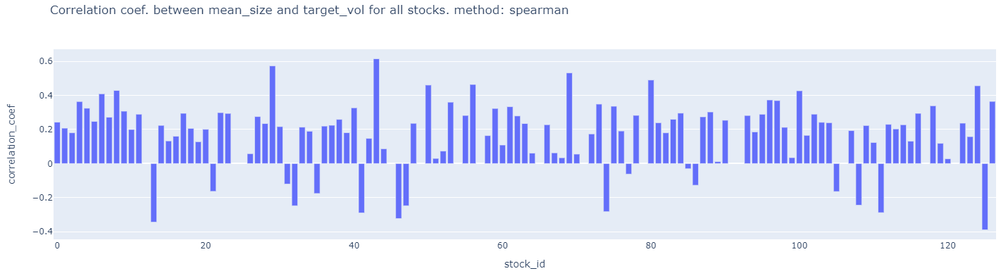

##### **ii) target (2nd 10 mins vol.) and order_count at the available times.** Aggregate **order_count** by taking standard deviation or mean at each time id. **Plot scatterplot of this against the corresponding target for each time id.**

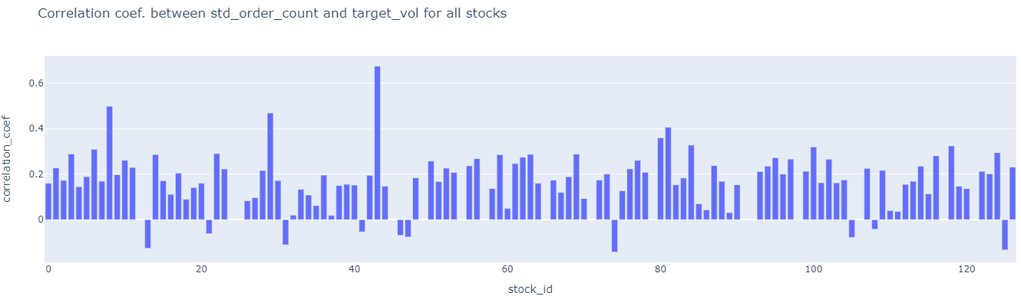

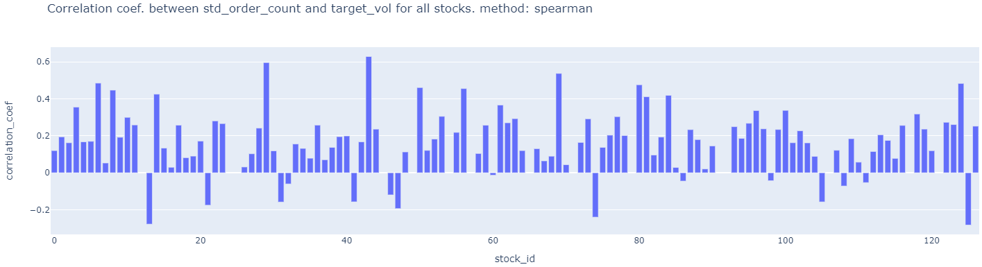

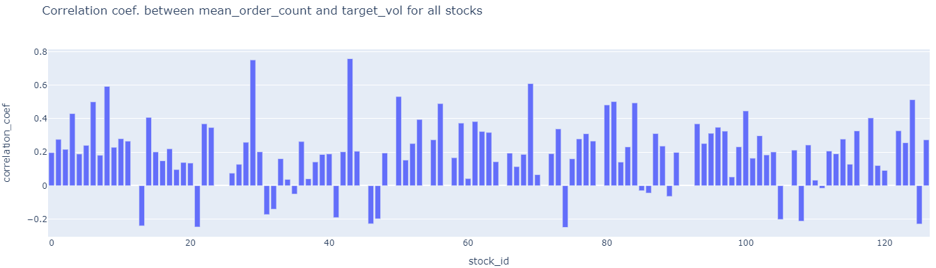

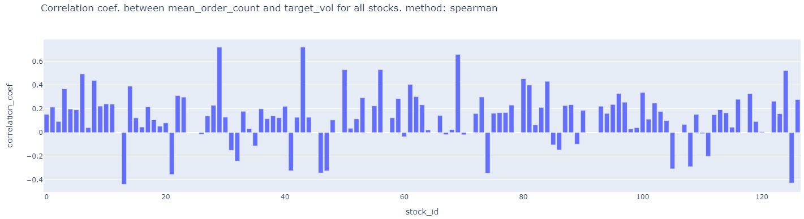

##### **2a)** Try to calculate spearman’s rank correlation for the cases of low linear pearson’s correlation. It might be higher due to non-linear correlation??? **DONE ABOVE. VERY SIMILAR.**

##### **3) check correlation in the first 10 mins. Target volatility between any two stocks and then identify which stocks have highest correlation. This is possible because even though time_id is shuffled, they are the same for each stock so the scatter plot does not care about time. 112 choose 2 = 6216. compute this numerically. DO NOT PLOT. Rank the correlations.**

**DONE and updated in Key Insights file.**

4) ## check how prices are distributed in the book data so that we can see how log(s_t2/s_t1) transformation of prices below and above 0 affects volatility. ## due to log nature check if non-linearity is visible. A point in graph below is for a single stock.

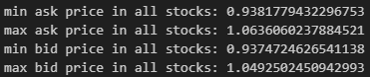

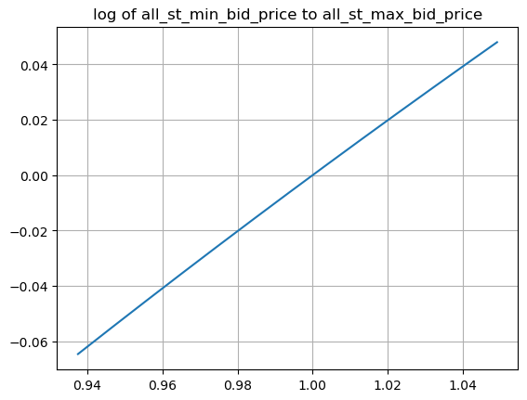

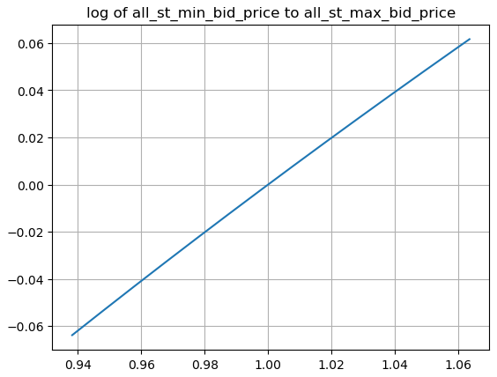

## Non-linearity is NOT visible as variance in price is low. so NO need to treat prices < 1 differently from prices > 1.

5) perform target volatility clustering across stocks using summary statistics features like mean, median, min, max etc..

Ans: The stocks volatilities are so homogeneous that it's difficult to separate/cluster them using summary stats features and hdbscan clustering algorithm. Maybe better features and/or different clustering algo. Might work. This is done in target_eda_across_stocks.ipynb file

Colors represent different stocks. 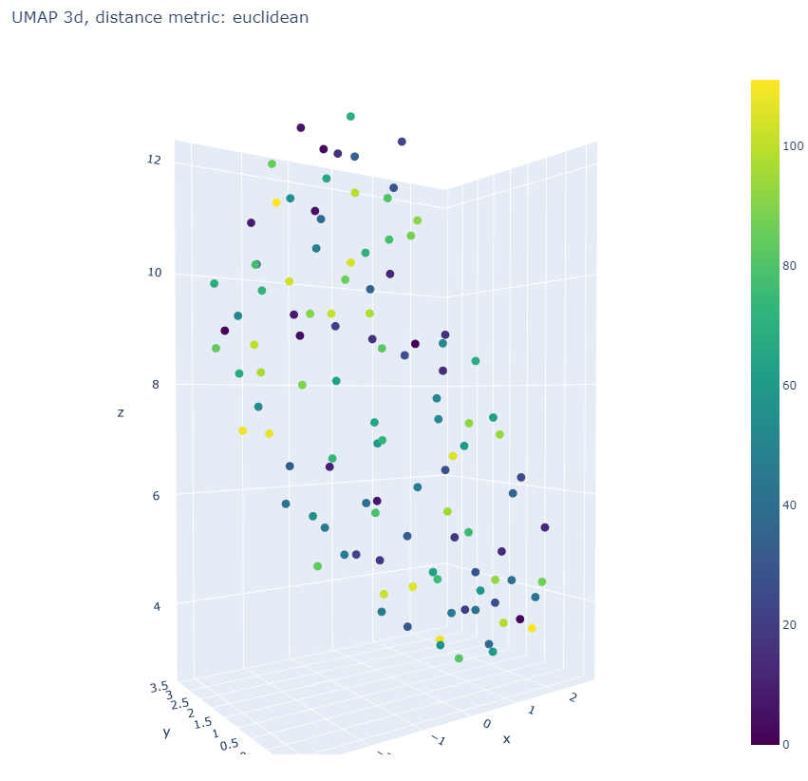

HDBSCAN analysis below was NOT fruitful!! .

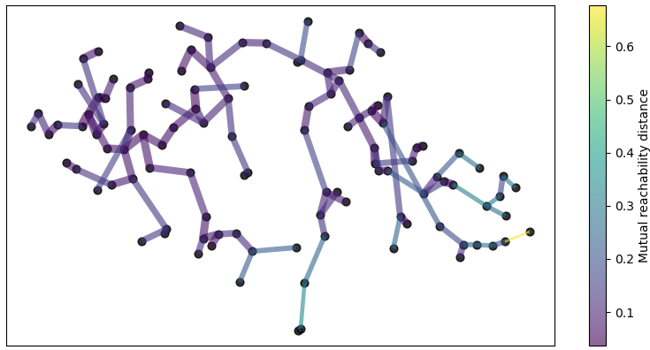

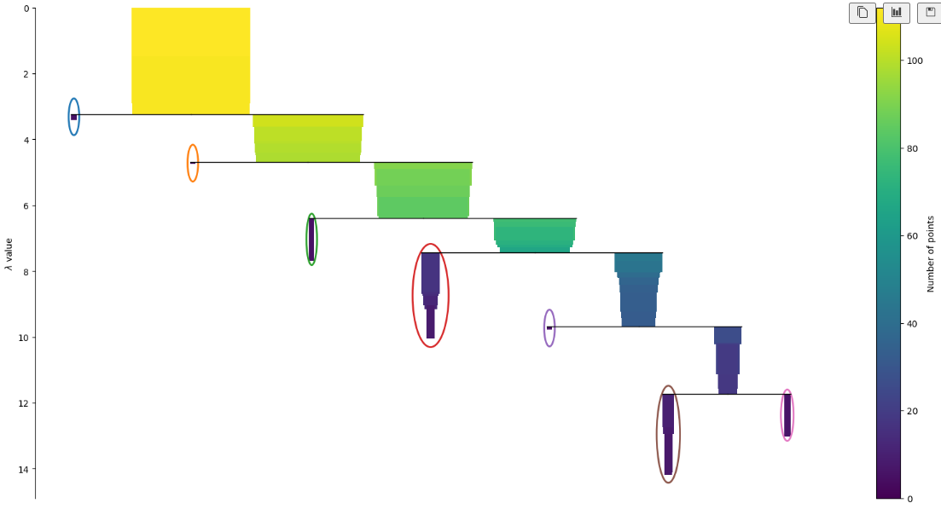

There are too many outliers in this clustering method.

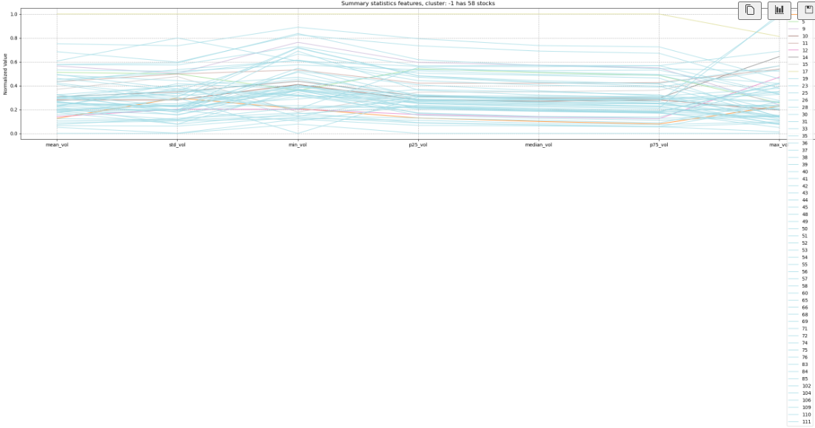

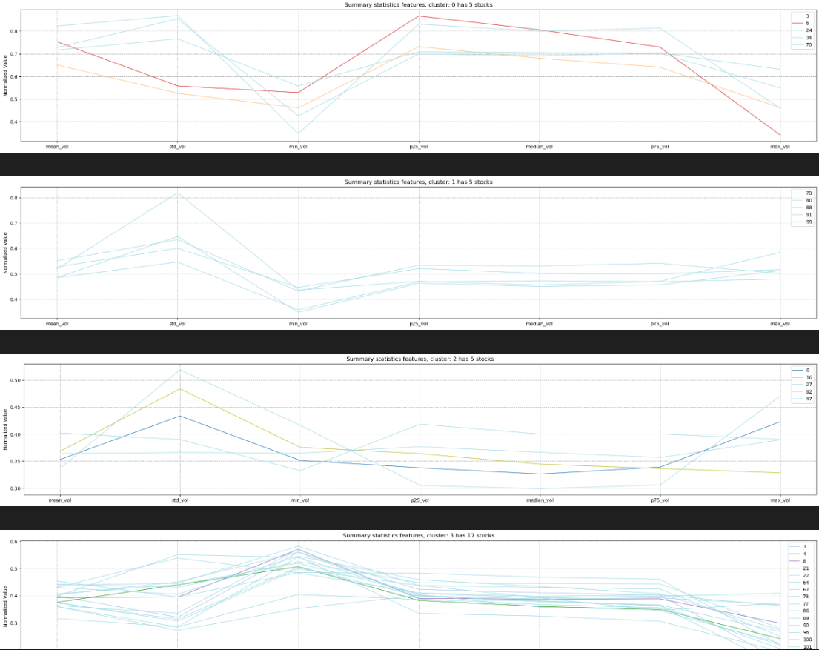

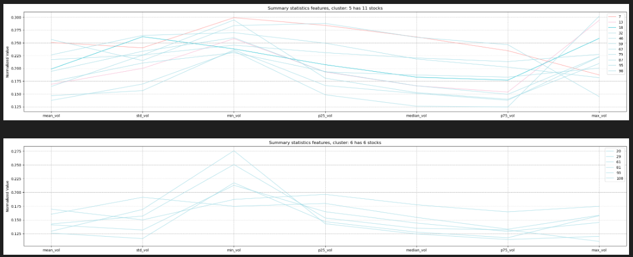

Hierarchical Agglomerative clustering using WARD linkage is better.

6) If two stocks (i.e. time series within a time_id i.e. 10 min interval) are highly correlated for many time_ids then we can improve the independent forecast of one stock by using the independent prediction of the correlated other stock. Reconcile the two predictions for the first stock to get more accurate forecast for 1st stock. Correlation captures shared patterns between the two stocks while independent stock prediction is based solely on within stock patterns. Do similarly for stock 2 using stock 1’s prediction. The other stock is acting like a covariate.

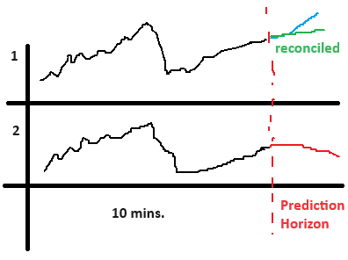

This analysis is SAME as in suggestion 3) which is **DONE and updated in Key Insights file.** Although data analysed is from TARGET and NOT from input features i.e. book_train and trade_train data. It’s better still.

7a) Check if minimum/maximum of bidsize1 and asksize1 in a time_id correlated with target realized volatitlity for the same time_id?

Graphs without level are level 1

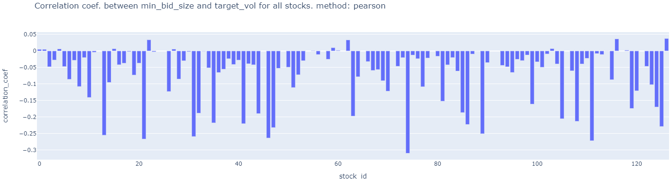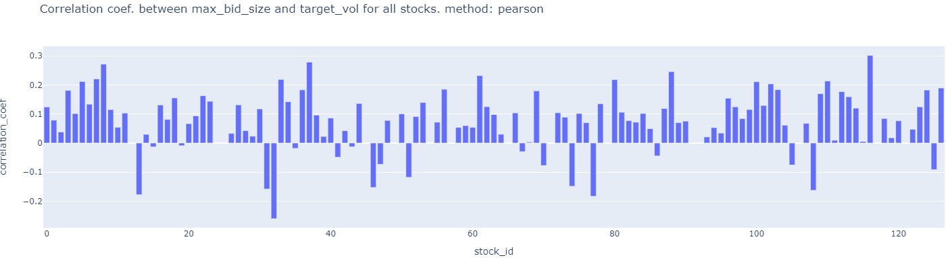

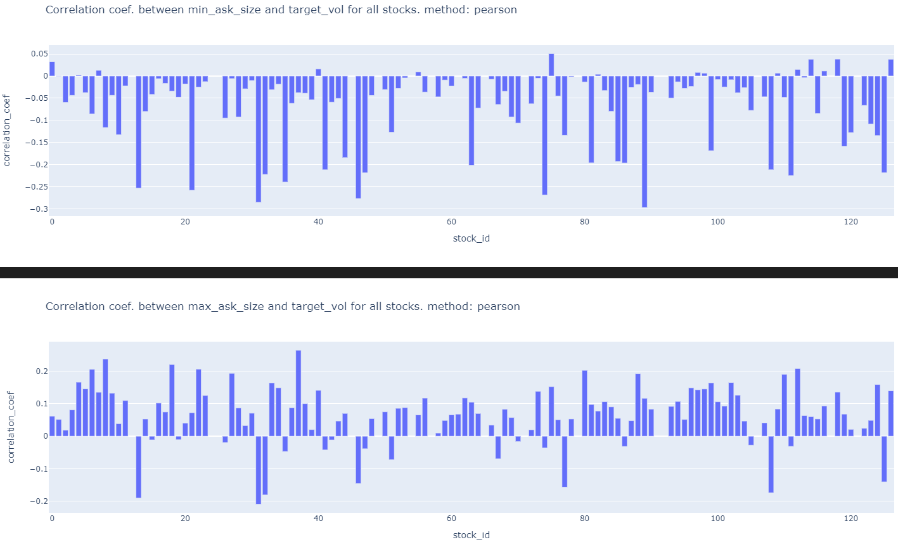

7b) Check if minimum/maximum of bidprice1 and askprice1 is correlated with target realized volatitlity for the same time_id?

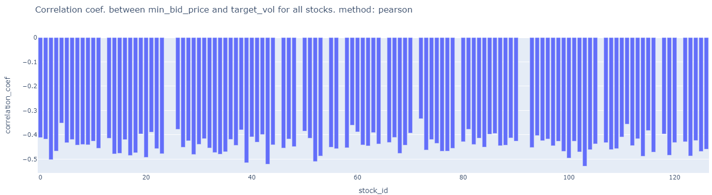

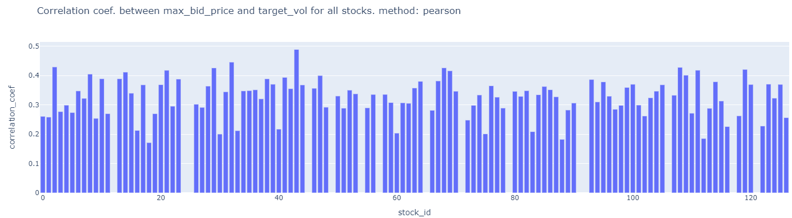

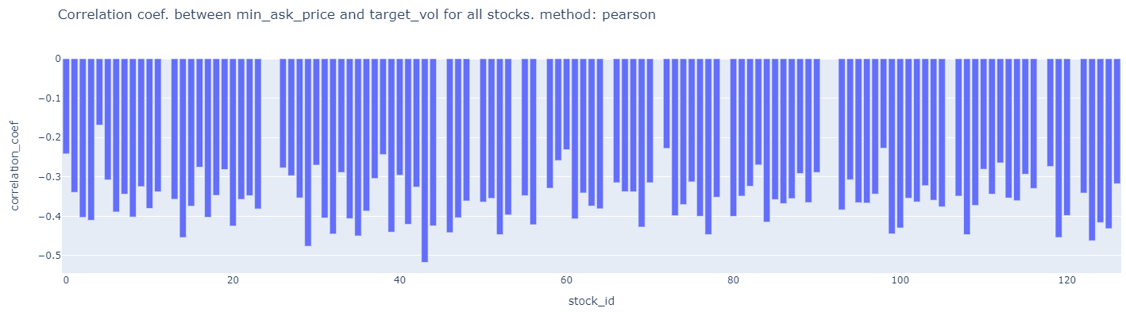

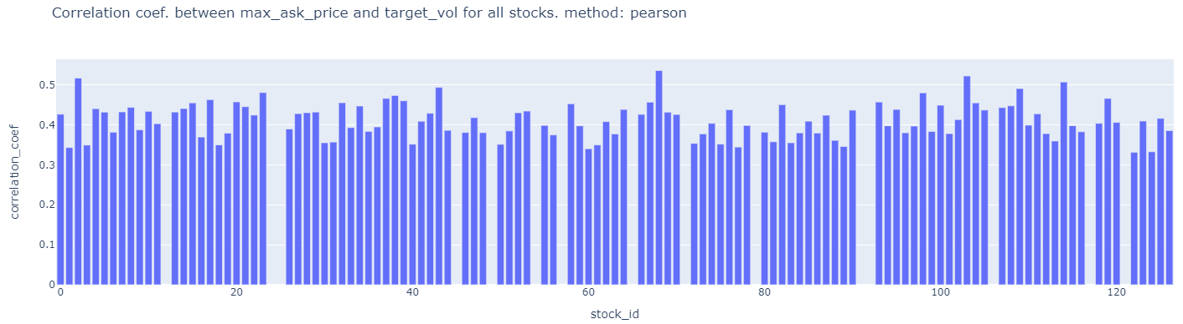

7c) check if the difference between minimum and maximum (i.e. range) of bidsize1 and range of asksize1 is correlated with target realized volatitlity for the same time_id?

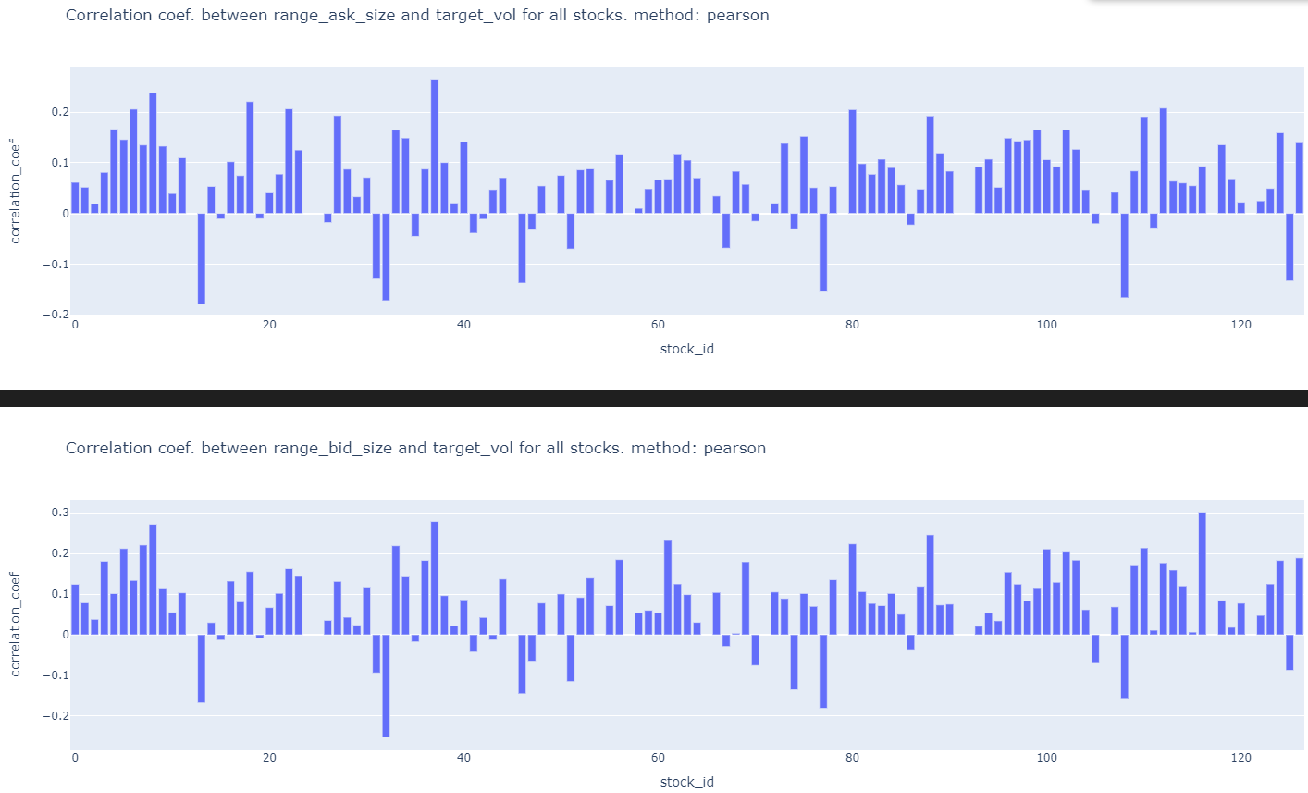

7d) check if the difference between minimum and maximum (i.e. range) of bidprice1 and range of askprice1 is correlated with target realized volatitlity for the same time_id?

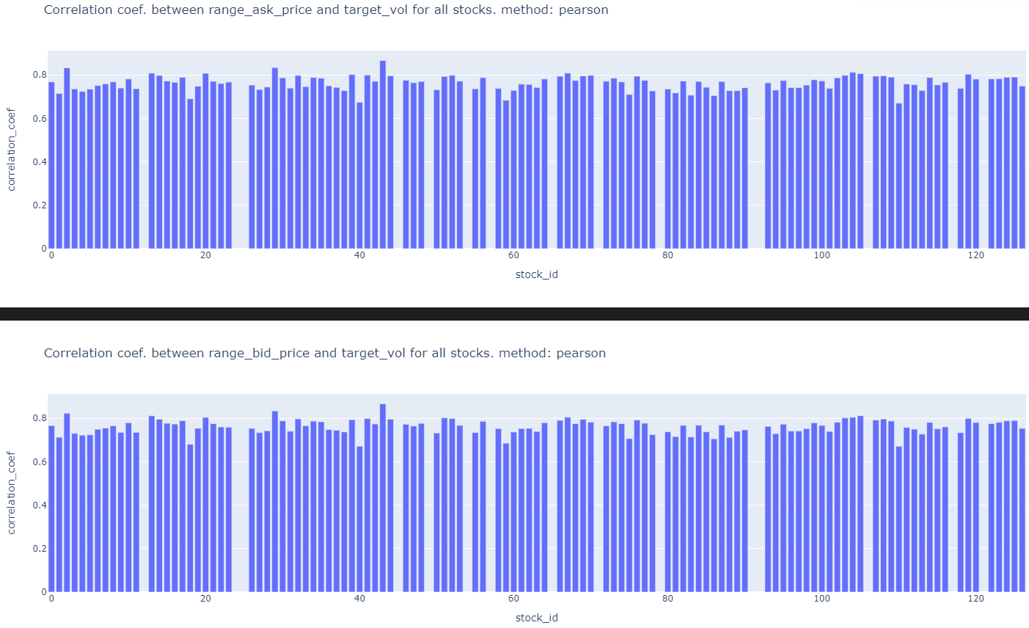

7e)Also check the correlation between (minimum – maximum) (i.e. range) vs. realized volatitliy of target. WHAT??

7f) Also check if the ~~average~~ sum of absolute bid_price1 in t2 minus bid_ price1 in t1 within a time_id is correlated with target. Check the same for ask_price1. Sum of absolute differences is better than average because price changes are too small and there are 600 seconds in a bucket so average values will be too small.

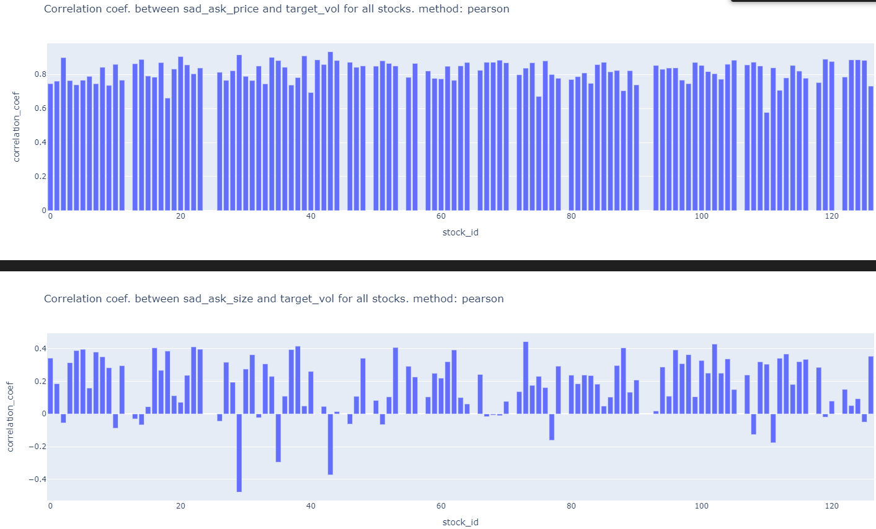

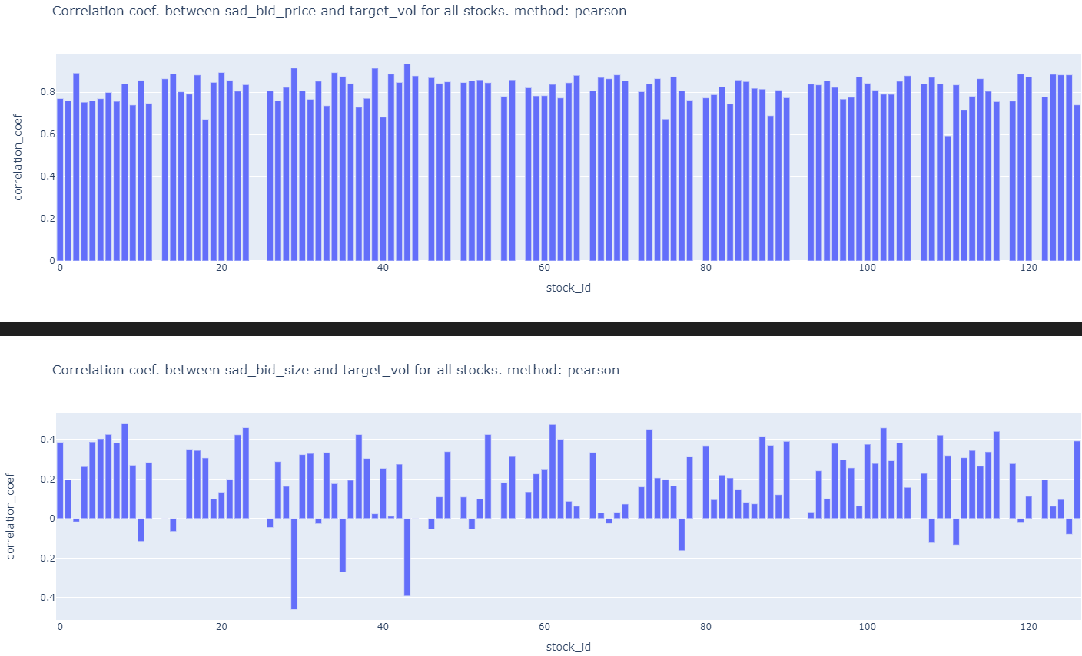

7g) calculate correlation between bid_price1 and ask_price1 in a time_id (positive correlation leads to a larger/smaller wap’s numerator) then check correlation with target realized voaltitlity.

7h) calculate correlation between bid_size1 and ask_size1 in a time_id (positive correlation leads to a larger/smaller wap’s denominator)

7i) Calculate pairs of correlation between a time series in this list [bid_price1, ask_price1] and this list [bid_size1, ask_size1] in a time_id (negative correlation leads to a larger/smaller wap) i.e. corr(bid_price1, ask_size1), corr(bid_price1, bid_size1), corr(ask_price1, bid_size1), corr(ask_price1, bid_size1)

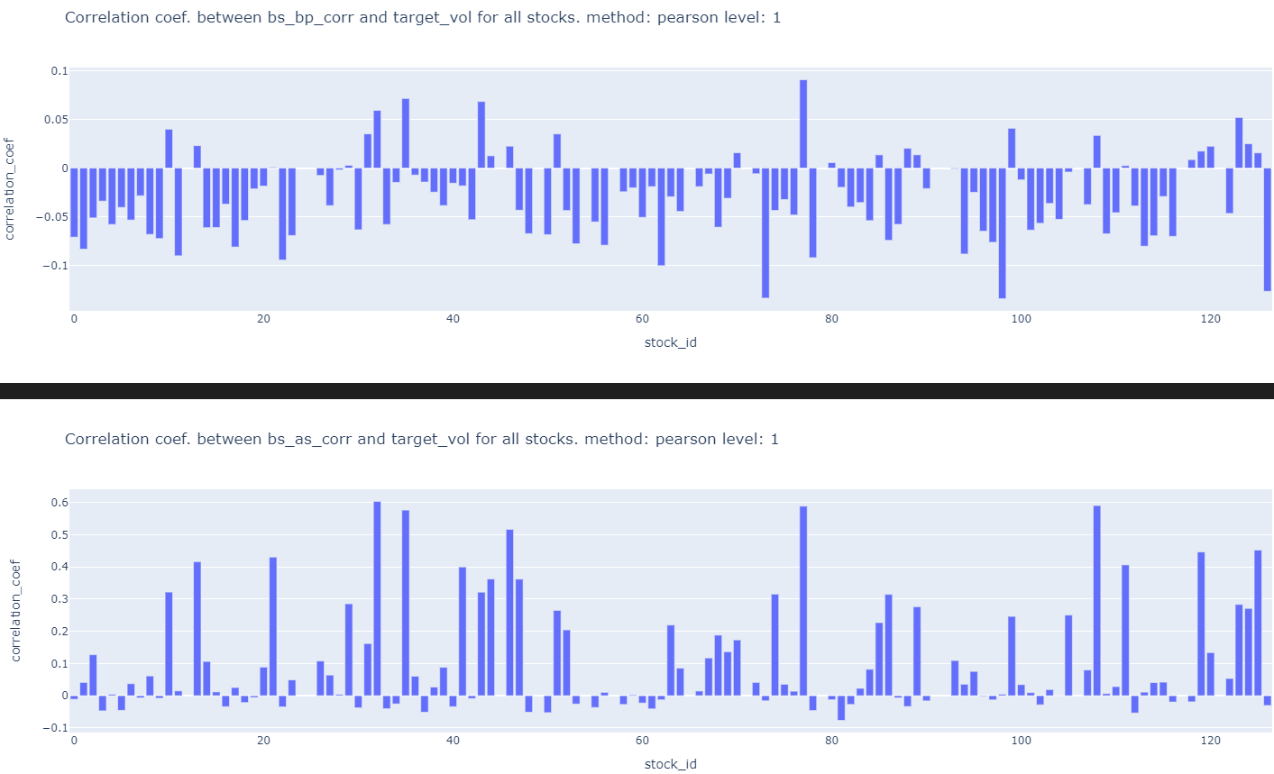

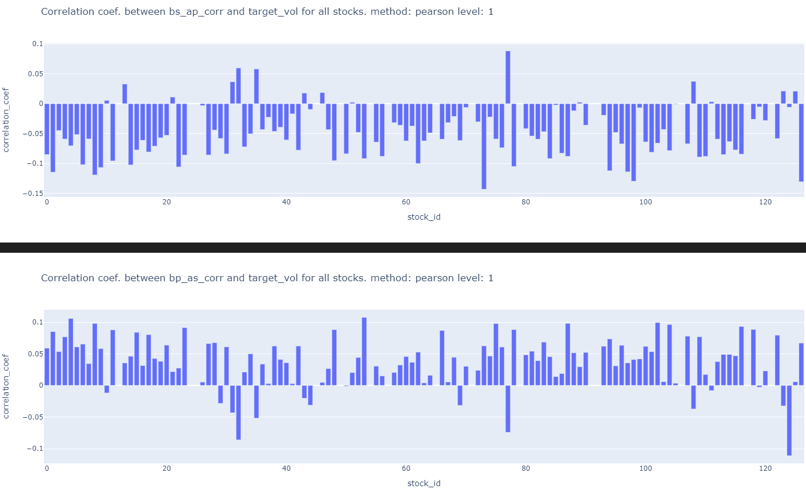

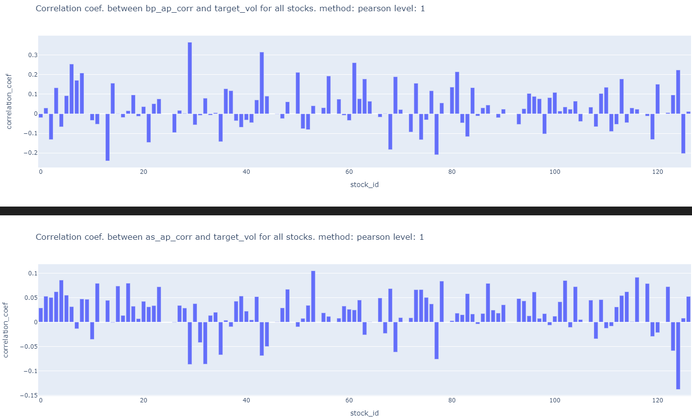

7j) Do the above for bid/ask_price2, bid/ask_size2 as well.

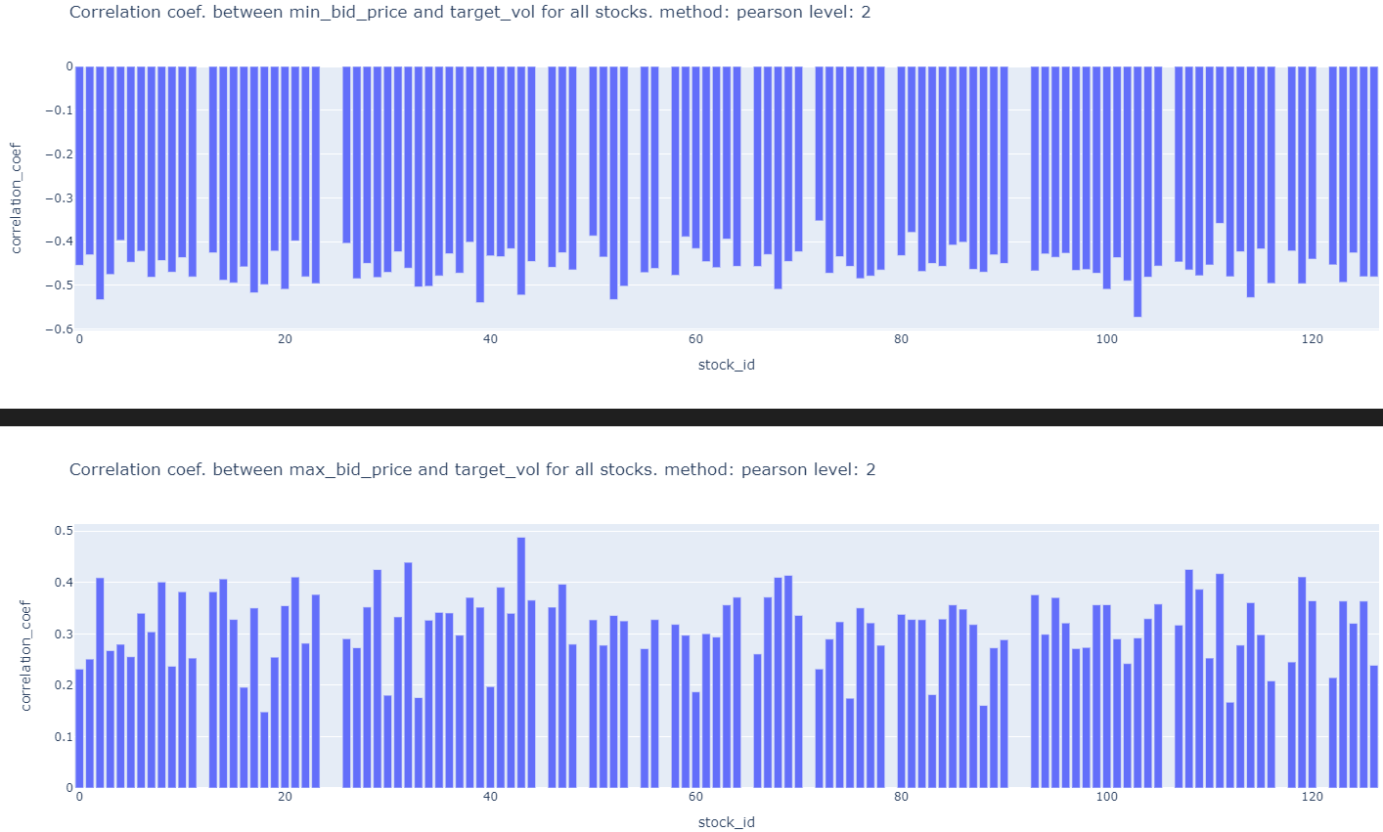

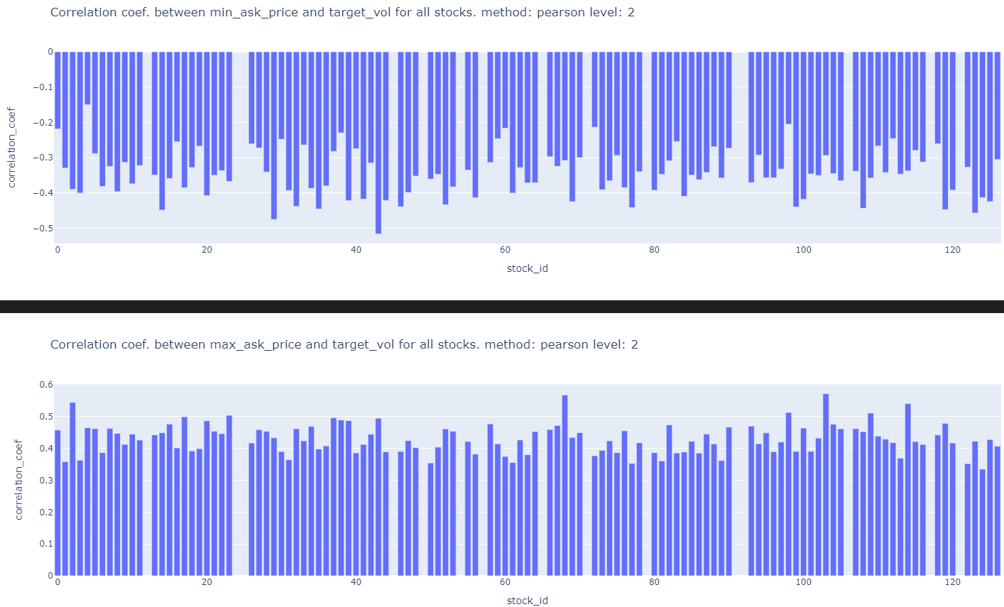

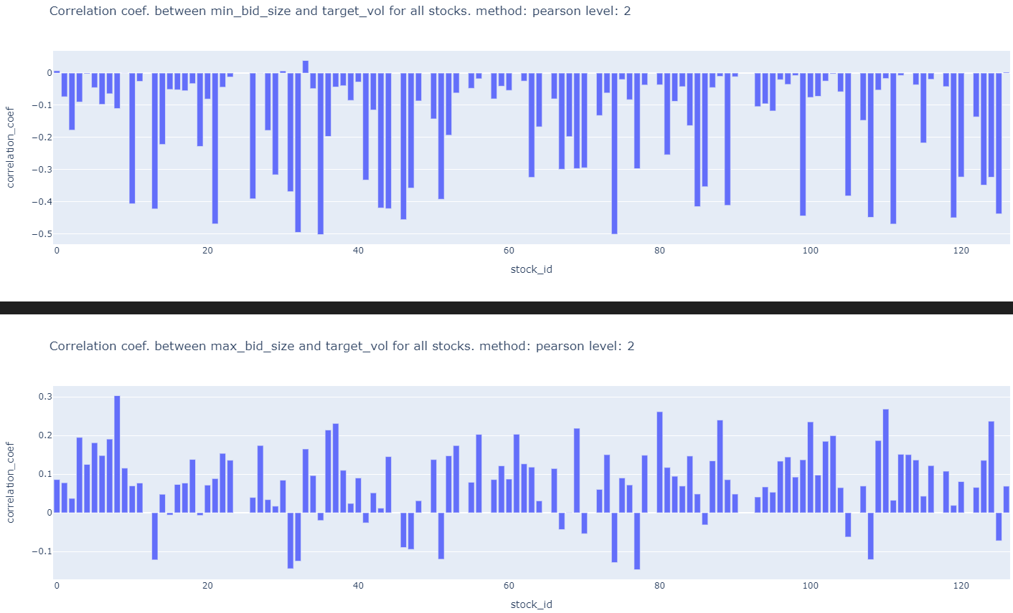

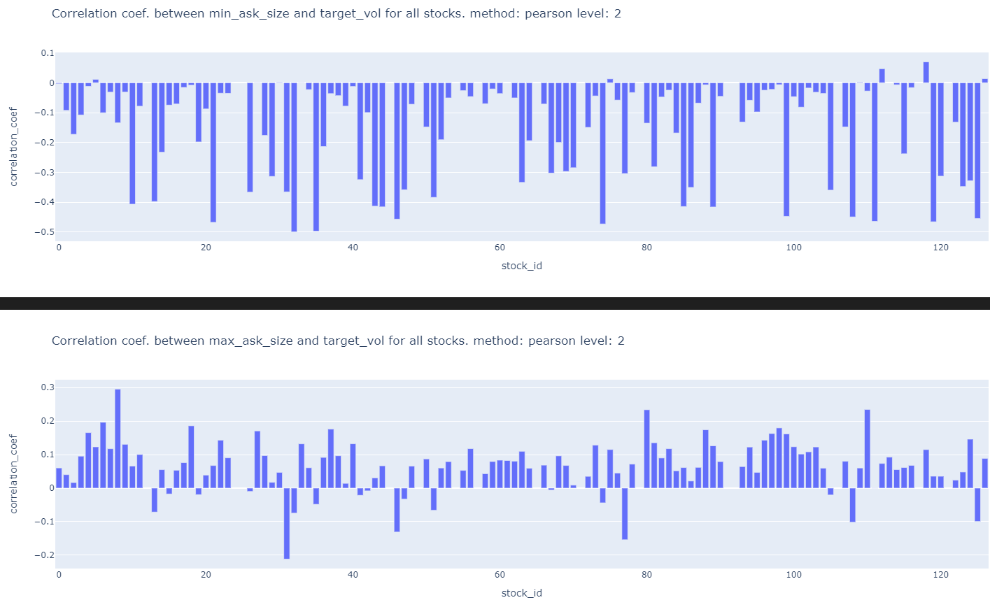

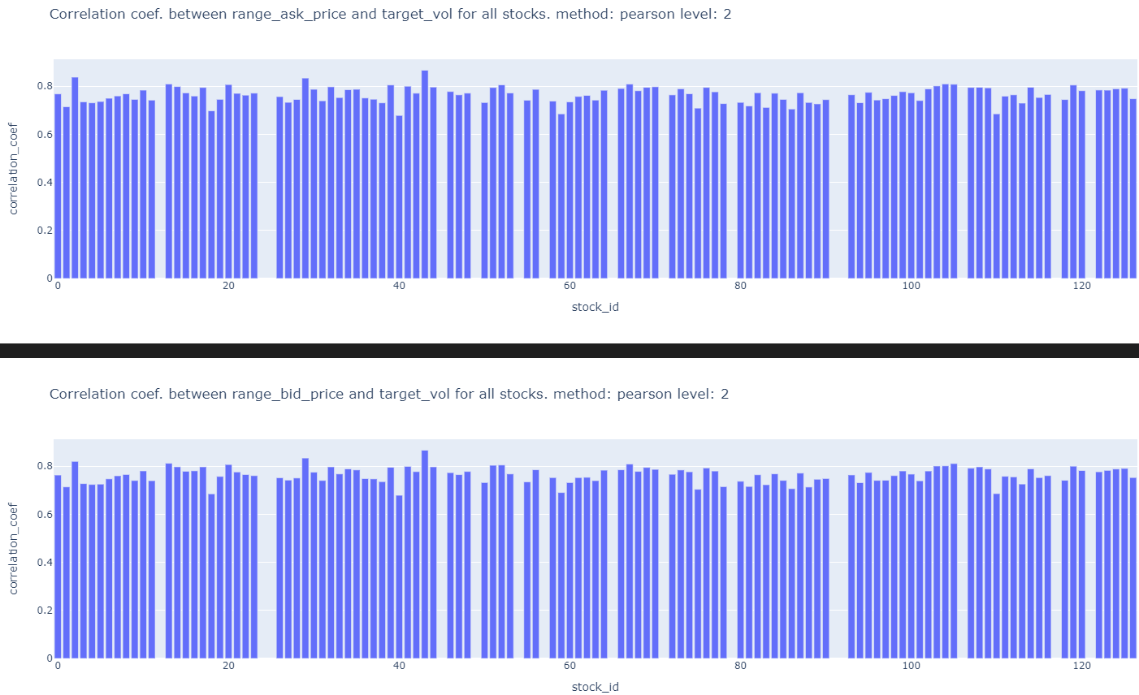

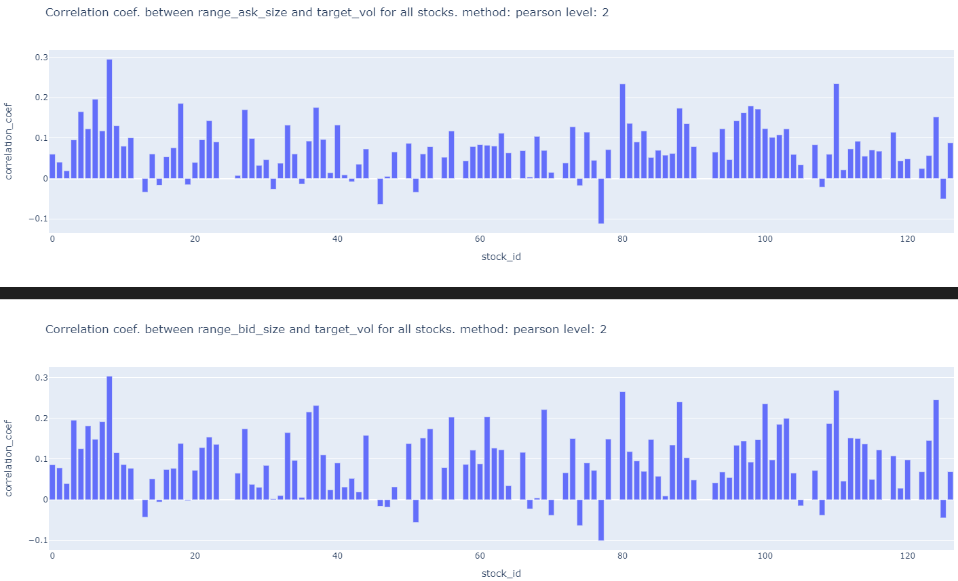

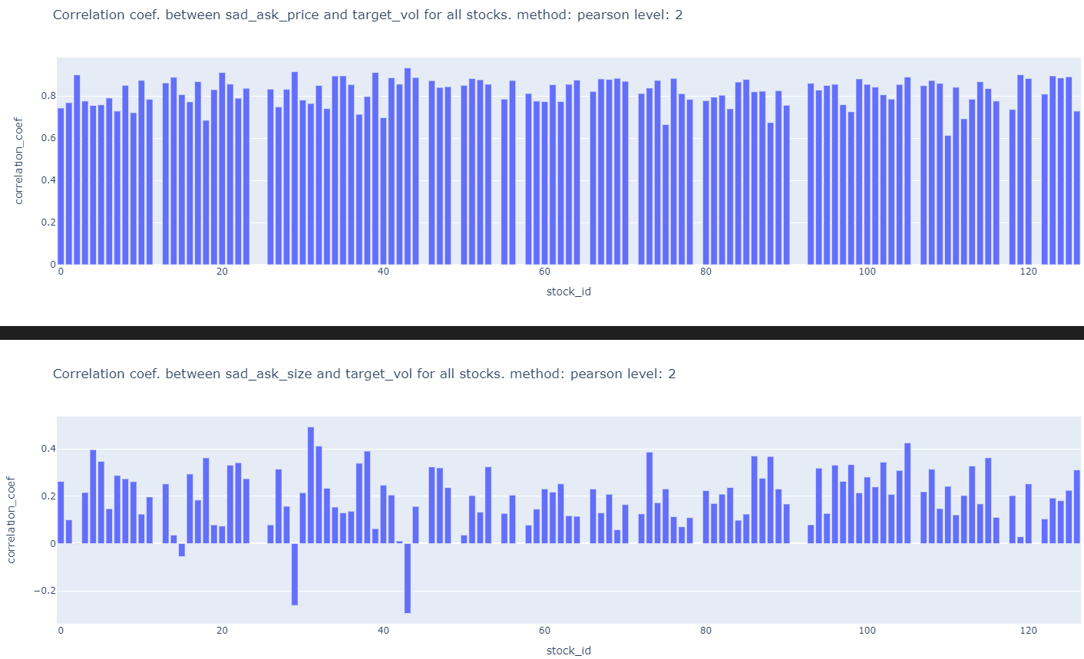

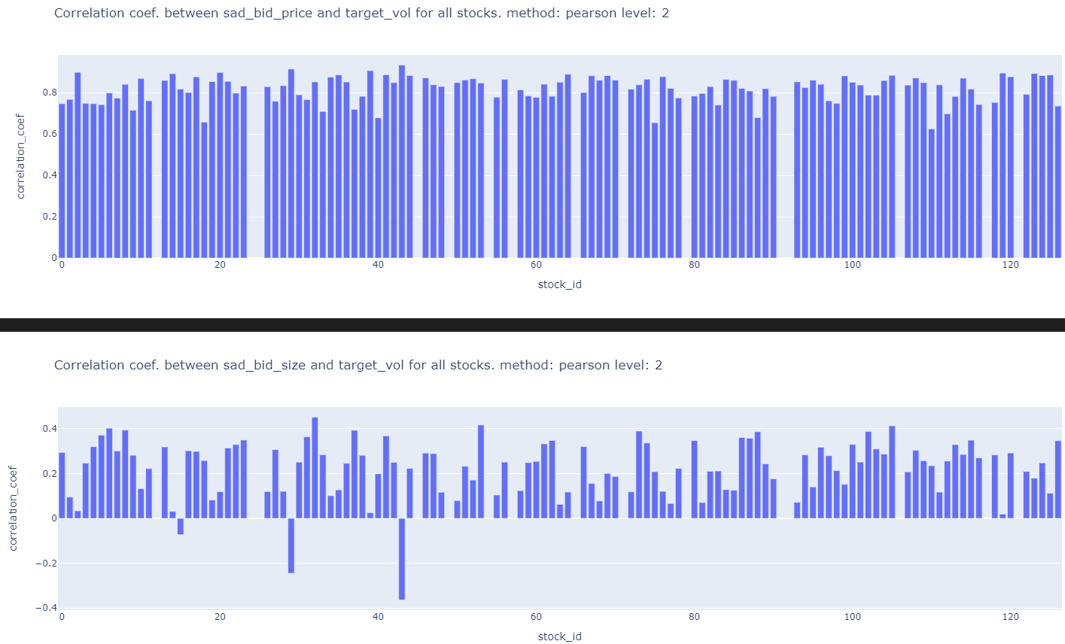

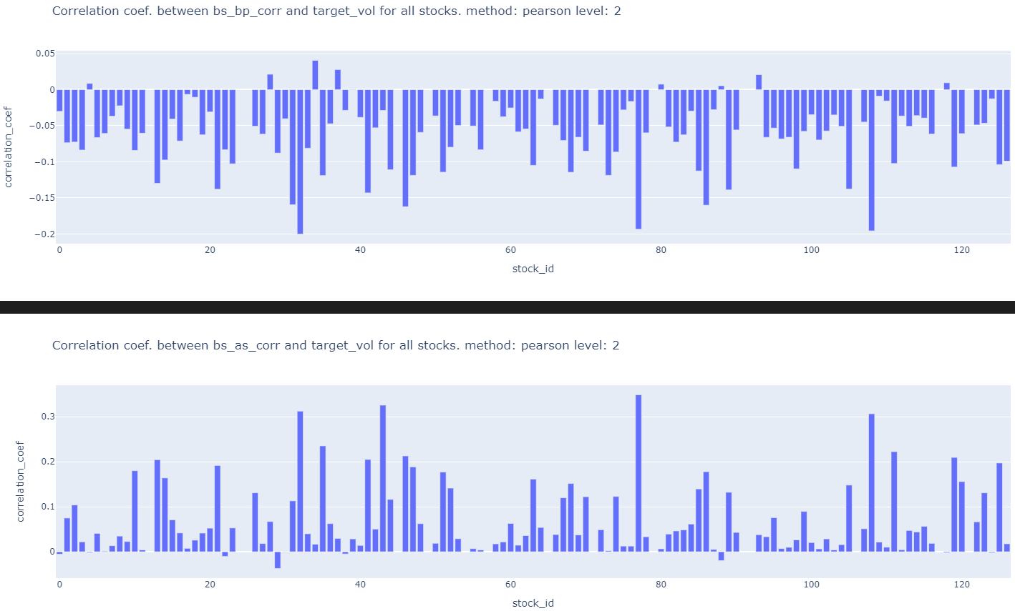

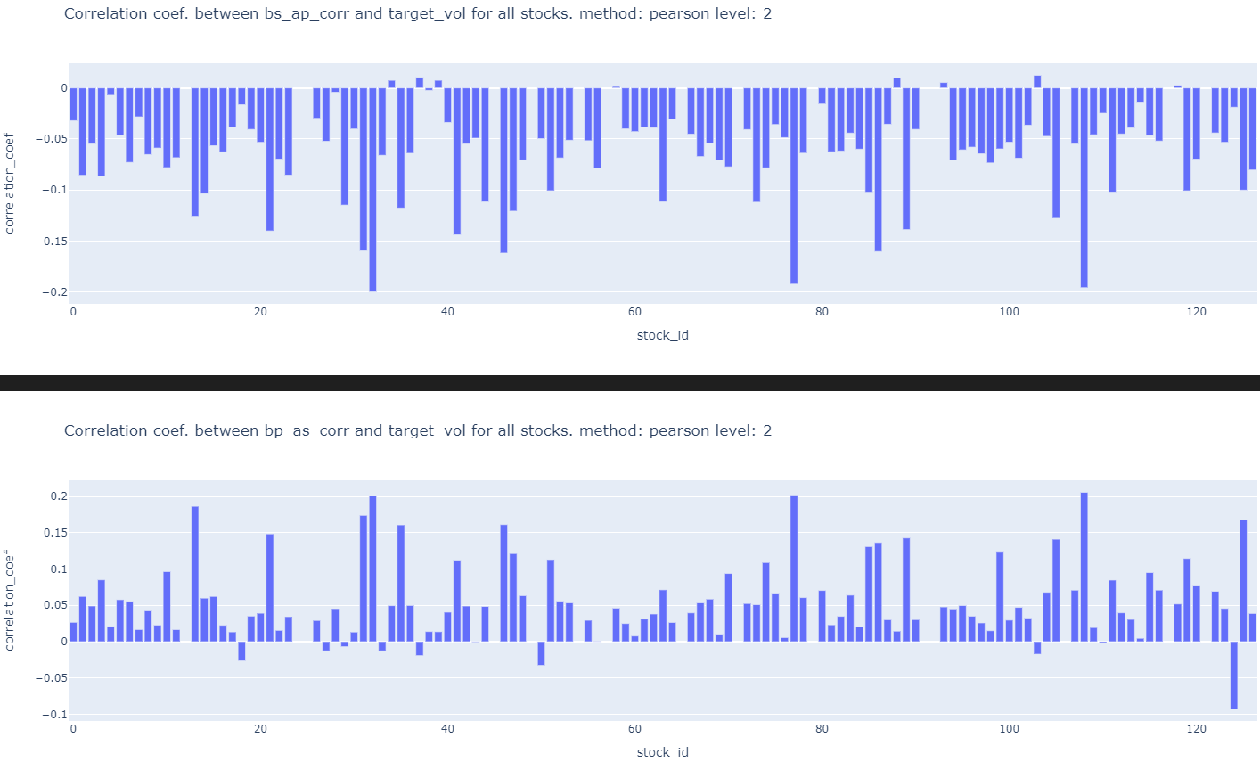

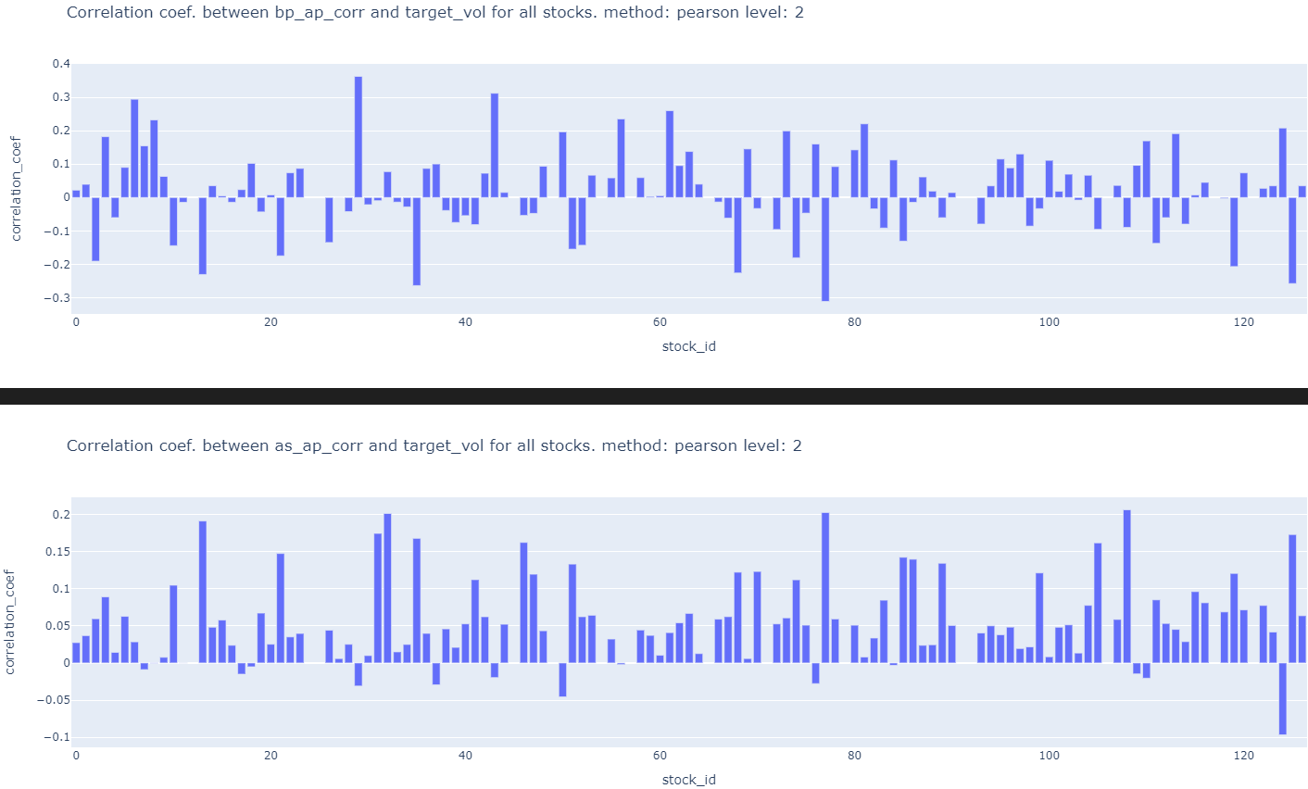

7k) Do the above for trade_train.parquet

Slight code modification has to be done.

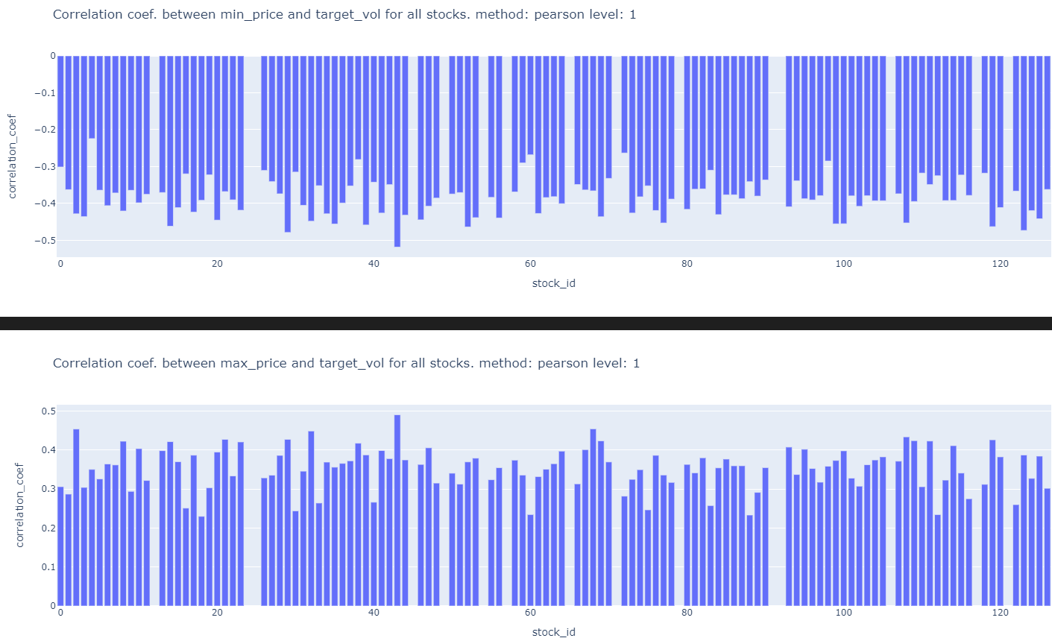

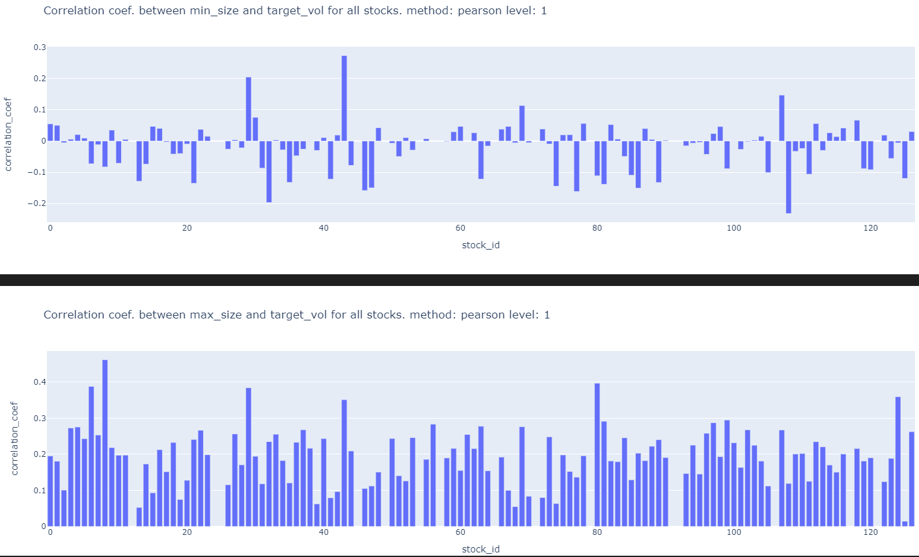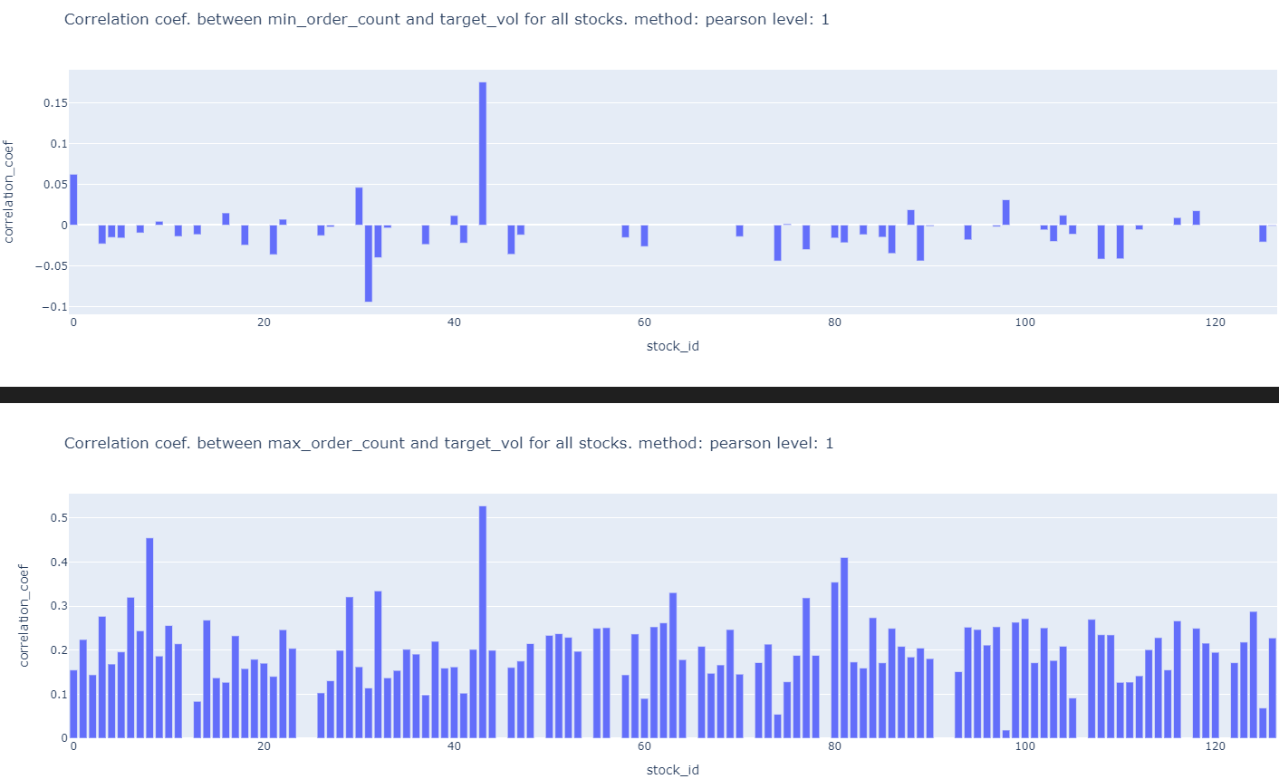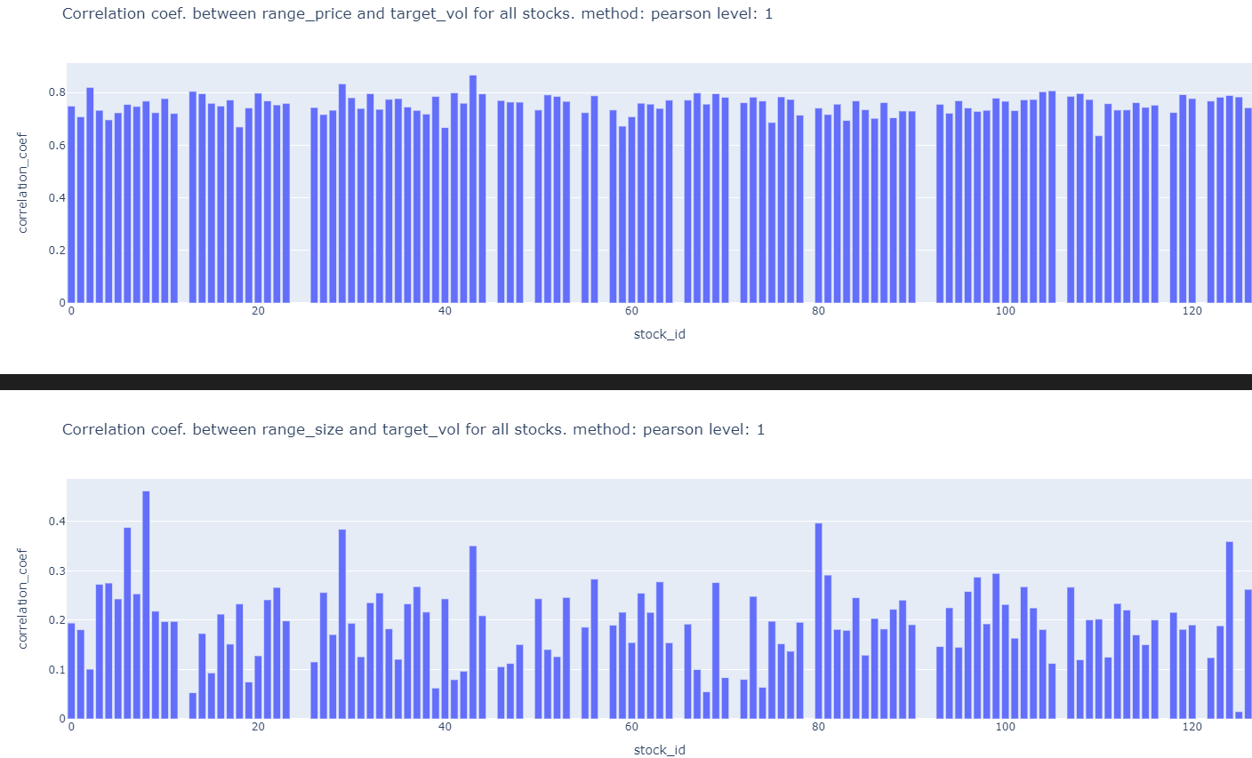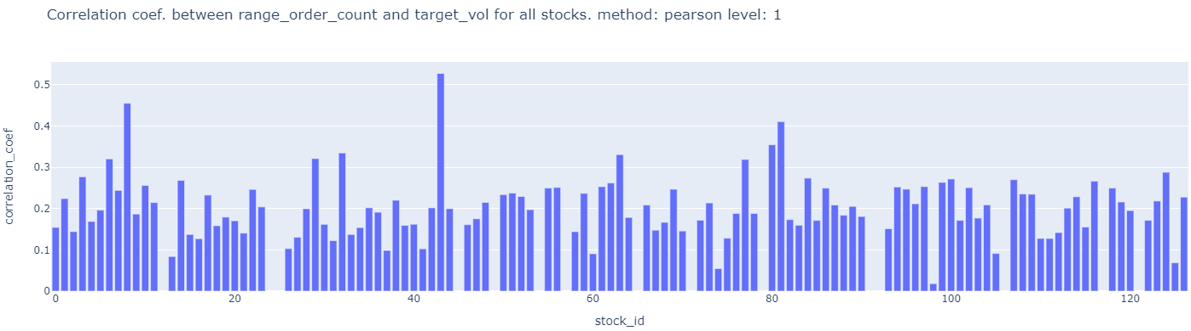

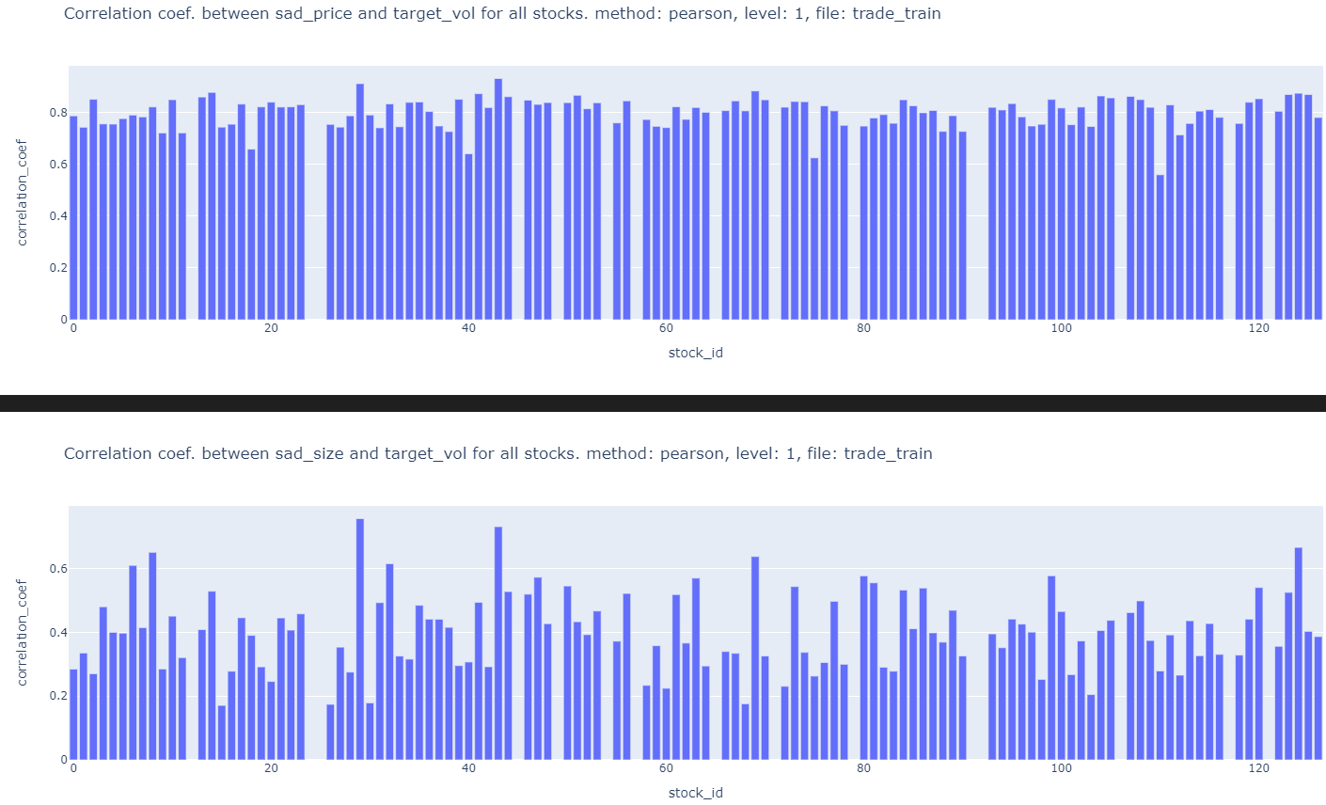

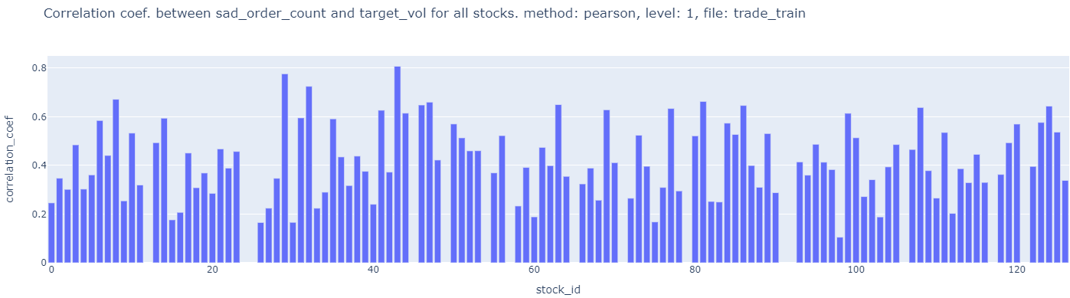

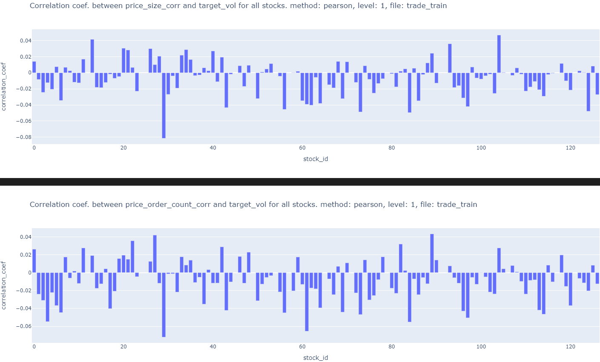￼

This is because from the WAP formula we can see that there is large variation in wap time series caused by min and max values of bidprice1 and askprice1 bidsize1 and asksize1 respectively. This affects returns and volatility. ALL of suggestion 7 is done in features_eda_within_stocks.ipynb

8) What features in the first 10 min that affect volatility in the next 10 mins?

Feature that has Delayed effect on volatility?

Ans: Rolling average or moving average volatility can identify a lasting trend of high or low volatility. (peeterson)

This is not good because summed volatility is an increasing function

Exp. moving average of INstantaneous volatility (squared returns) can be used

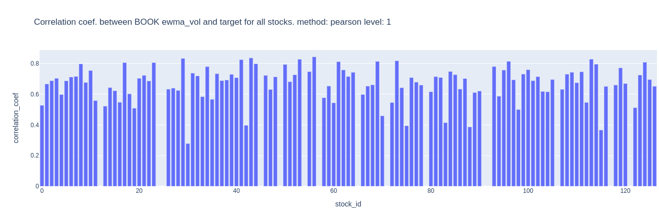

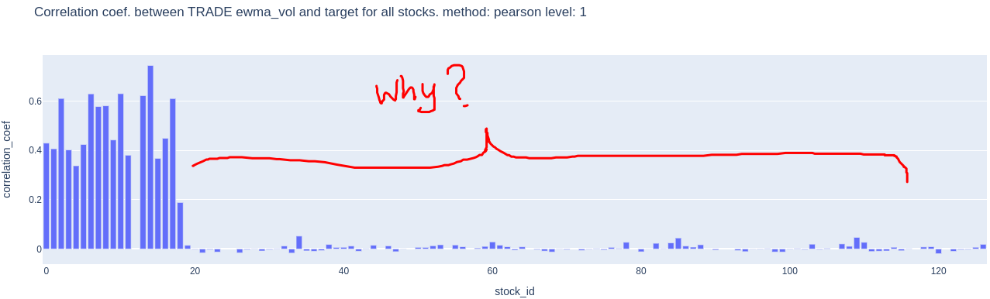

9) Use a GARCH model on the time series available in the first 10 mins. to predict volatility into X (X<10) minutes of the second 10 minutes. Check correlation for different average x minutes realized volatility against the target realized volatility and choose the best x minutes of average volatility for each stock. (peeterson)

9a) The cons of a GARCH model is that the GARCH model does not distinguish between the impact of positive and negative negative returns. However, the leverage effect states negative returns have a greater impact on volatility and volatility clustering than positive returns.Therefore use GJR-GARCH or EGARCH.

Use Apache spark to analyse 166 Million rows.

9b) use the clustering (of correlation matrix) done on pearson correlation of target in fitting a multivariate GARCH model.

9c) Can you reverse engineered time_ids to create more contiguous trainings set and together with time_id can be used in prediction.

https://www.kaggle.com/c/optiv￼er-realized-volatility-prediction/discussion/275825

10) Plot ACF of squared returns time series to leverage the Volatility clustering (persistence) phenomenon to predict/extend into second 10 minutes. Remember volatility is square root of sum of squared returns.(jx)

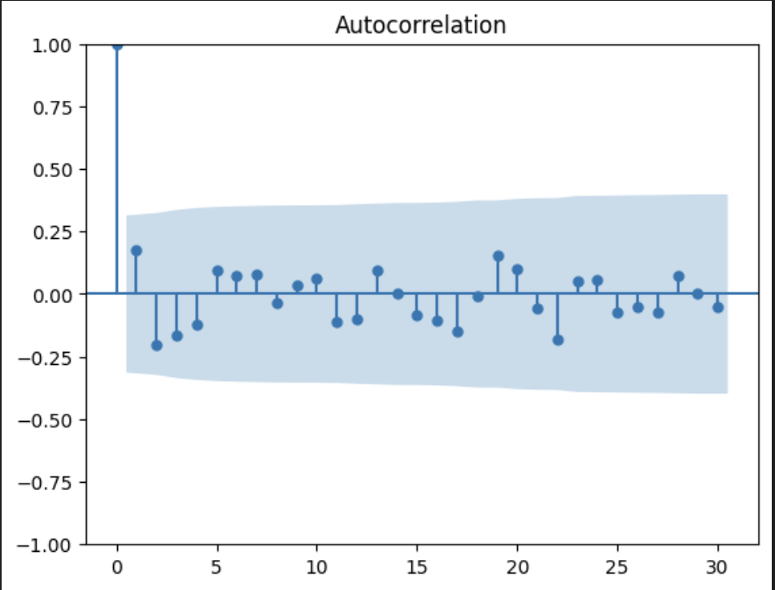

All autocorrelation values are under blue range so they are all close to zero

Series is random?

Yes, so it’s random or coming from a white noise distribution. We cannot predict instantaneous values but we can learn a probability distribution from these returns and predict things like averages, standard deviations and long term behaviours

Ohh

~~11) WAP price trend up/down in the second 10 mins is negatively correlated with realized volatility in the 2nd 10 mins. This is called the leverage effect. Can we forecast trend in the 2nd 10 mins? Try using moving average of WAP of different window sizes and check if current price is above or below average. to predict short term trend in 2nd 10 mins.~~

12) When calculating realized volatility did you first ffill for the missing book order seconds?

It does not make a difference because constant price/size/order_count lead to zero volatility.

13) Compute Wap2 using ask/bid_price/size 2.find the correlation of realized vol. Using level 2 wap with target and find the correlation of realized vol. Using average wap with target. Code is already available in features_eda_within_stocks.ipynb in cells 1, 2, 225, 230, (jiaxu)

￼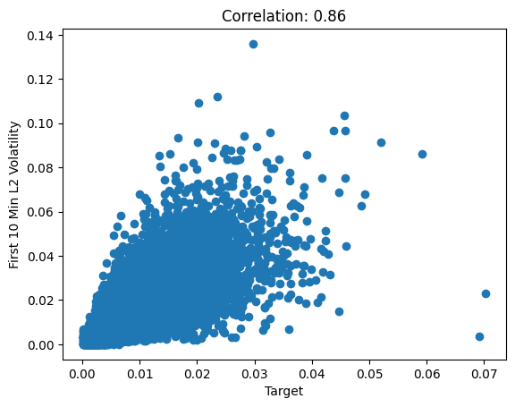

Correlation for wap2 and target

￼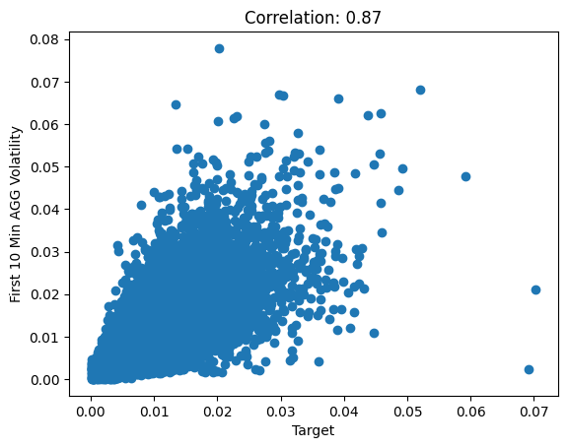

Correlation for aggregate wap and target

aggregated wap calculated using ((bidprice1 * asksize1) + (bidprice2 * asksize2) + (askprice1 * bizsize1) + (askprice2 * bizsize2)) / (bidsize1 + asksize1 + bidsize2 + asksize2)

14) Just use skew, kurtosis, min, max, std,and all other statistics for each bid ask wap etc… in each time id. (peeterson)

15) Check if Standard Deviations of Price Variables is POSITIVELY Highly Correlated with Target (peeterson)

16)Check if Minimums of Prices Variables is NEGATIVELY Highly Correlated with Target; (peeterson)

17) the std of bid price was often more highly correlated with the target than the wap calculation. (peeterson)

18) Use bid ask spread. ask_price1 / bid_price1 - 1 (jiaxu)

(ask-bid)/bid

￼

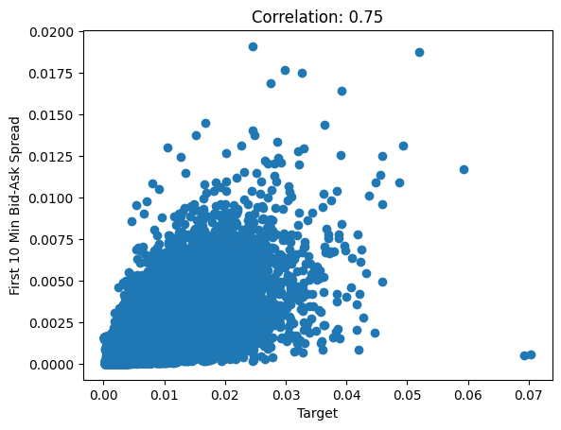

Used mean to aggregate bid ask spread for each row_id

19)wap1_log_high_low - this is log(highest wap1 in interval) - log(lowest wap1 in interval)

Implement above feature (jiaxu)

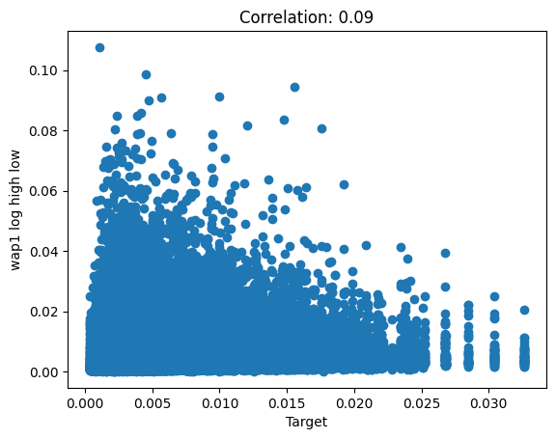

20) Liquidity features:

Spread-related measures, Volume-based measures , Price-based measures

<https://www.kaggle.com/competitions/optiver-realized-volatility-prediction/discussion/276137> and Chatgpt 🙂

LIquidity describes how much of an asset can be purchased or sold immediately without moving the market (i.e. significant price changes). It is inversely proportional to volatility and bid-ask spread. It is directly proportional to trade volume/ size.

Generally, trades happen smoothly when the trade execution price (i.e. let’s call it “realized” WAP) is a compromise between the bid and ask price i.e. it lies in between to keep both the buying and selling party happy. The bid and ask price should approach this WAP price with time so that trades can happen at this price. This is like price discovery (equilibrium price). In this equation we are measuring how far away we are from this to happen. incorporating the order size also improves this information and this is defined as liquidity. Current time’s liquidity is an indicator of the future volatility to come. WAP is calculated all the time but “realized” WAP is when trade execution happens at that time.

First we need to find the wap (i.e. equilibrium price) for a given bid price, ask price, bid size and ask size. This can be found when we minimize the liquidity function. MInimizing liquidity does not mean liquidity is low value. E.g. 1000 ican be a minimum of a function similarly 10 can be a minimum of a function. Value of 10 is lower liquidity than 1000. The minimum is the correctly measured value of liquidity at that point in time. At different times we calculate different liquidity. The computed objective function (at the minimum) is computing liquidity based on parameters of the objective function. MInimizing this liquidity objective function helps us find the WAP that the bid_price and ask_price is likely to move towards in the future.

Given bid_size, bid_price, ask_size and ask_price, let us try to calculate the “realized” WAP at which trade execution is likely to happen in the future.

If WAP is far away from bid_price/ask_price then it indicating the bid ask spread is high. This is not ideal for trades or we can say it is ILLIQUID. Volatility has to come in the future and move prices in order to make it more LIQUID.

## **Defining Liquidity**

In finance, liquidity describes how much of an asset can be purchased or sold immediately without moving the price significantly. A reasonable numerical definition of liquidity then should start from the following assumptions:

liq_1 = sum_i[ bid_size_i/(wap_1 - bid_price_i) + ask_size_i/(ask_price_i - wap1)]

or for wap_2:

liq_2 = sum_i[ bid_size_i/(wap_2 - bid_price_i)**2 + ask_size_i/(ask_price_2 - wap1)**2]

1. moving bids closer to asks always increases liquidity
   1. I.e. smaller (wap_1 - bid_price_i)and smaller (ask_price_i - wap1)
2. increasing order sizes always increases liquidity
   1. I.e. Bigger bid_size_i and Bigger ask_size_i
3. adding additional orders to the book always increases liquidity
   1. I.e. sum_i Refers to levels of the order book.

The above two behaviours are captured in the following equation as well.

f(x) = -bid_size*log(x-bid_price) - ask_size*log(ask_price-x) over the range [bid_price, ask_price].

X-bid_price = missing price on bid side. Ask_price - x = missing price on ask side.

bid_size*log(x-bid_price) = missing bid volume. ask_size*log(ask_price-x) = missing ask volume.

Think of f(x) as the total missing volume. We want to find a price that minimizes the total missing volume. Missing volume means no trade can take place. When missing volume is minimized/less then trade can take place.

f(x) = bid_size*1/(x-bid_price) + ask_size*1/(ask_price-x) over the range [bid_price, ask_price].

In this equation we assume WAP i.e. x, x <= ask price or x >= bid price. AND bid price != ask price.

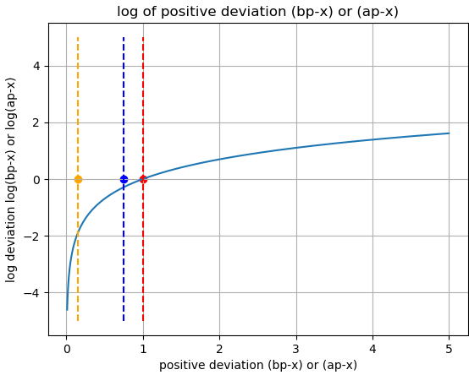

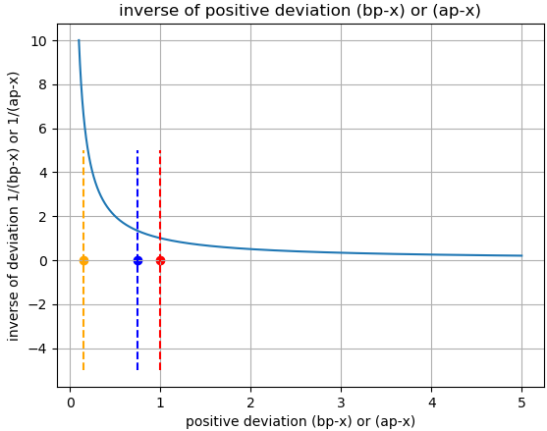

Instead of log we can also use other functions that can be computed faster. The function just has to have an asymptote at x=0. E.g. 1/x . Note: sign change in cost function.

Firstly, the deviation is highly unlikely to be greater than 1. Deviation closer to zero deviation incurs more cost.

In the code the wap (equilibrium price) is computed using the function full_book_wap_bisect( df_book, lvl=0) using a bisection algorithm iteratively and the wap moves towards the price (either bid or ask price) which has bigger bid or ask size and smaller . increasing lvl increases importance/weight of distance with respect to size. Higher lvl. Additionally, odd values of lvl make s negative and if bid size/price > ask size/price then p moves towards ask price. Similarly, opposite is true. For even values, always pushed towards ask price??

21) Explore the rest of the 46 features in clustering analysis to see if there are other feature that give a high score?

Ans: No need to try this because Jager must have tried this already. Actually we can try our features through this clustering method.

# **Feature SELECTION**

22) always check correlation between features to ensure no multicollinearity issues. (However, this method has the downfall of only checking “LINEAR/Spearman” correlation )

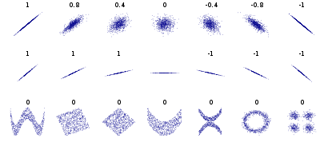

How to capture last row correlation patterns in fig above? Need a non-linear measure or feature transformation to make them like row 1 or row 2.

23) features target real vol

7 pc target real vol

<https://neptune.ai/blog/feature-selection-methods>

<https://machinelearningmastery.com/feature-selection-for-regression-data/>

<https://machinelearningmastery.com/feature-selection-with-real-and-categorical-data/>

Filter-based methods

Borutapy

QQ-plot

<https://stats.stackexchange.com/questions/101274/how-to-interpret-a-qq-plot>

<https://xiongge.shinyapps.io/QQplots/>

***Be sure to REMOVE all the columns with the word ” TARGET “ in it before splitting the data into x and y for training. E.g. log_target and log_target_standardized***

Try to use these different columns as targets in training and see if it can improve the prediction performance.

**EXPLORING FEATURES AND INITIAL ELIMINATION.**

* Jager’s features from 0:152 , stock_id to target
* Our features from 153:237 ,log_target to pear_corr_90_clusters_labels

3.Wap1_log_price_ret_vol: volatility of wap1 returns

4. log_liq2_ret_*_wap_eqi_price1_ret_vol: product of log returns of liq2 and volatility of wap1 equilibrium price returns

5. exp_log_liq1_ret_*_wap_eqi_price1_ret_vol: exponential product of log liq 1 returns and volatility of wap1 equilibrium price returns, exponential amplifies positive returns and diminishes negative returns, needs to normalize distribution scale

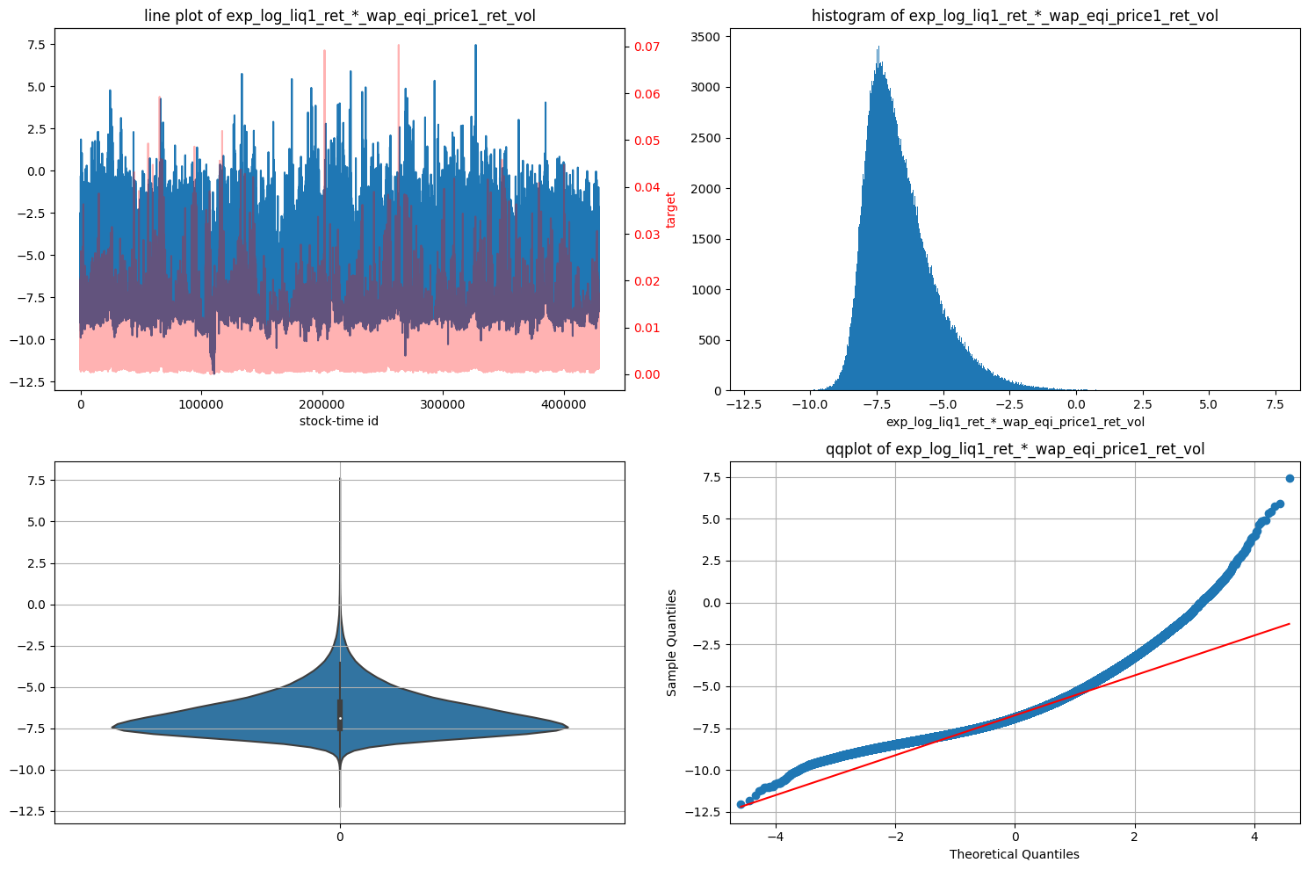

6. exp_log_liq1_ret_*_wap_eqi_price1_ret_vol_2: different cluster from 5.

7. Wap1_log_price_ret_per_liq2_vol_stnd: all missing values

8. Wap1_log_price_ret_per_spread_sqr_vol: volatility of wap1 returns per unit of   
Spread

9. log_liq2_ret_*_wap_eqi_price1_ret_vol_15_ratio: ratio of mean of first 15 buckets to last 15 buckets of one time id, derived from 4.

10. Wap1_log_price_ret_per_liq2_vol_15_ratio:

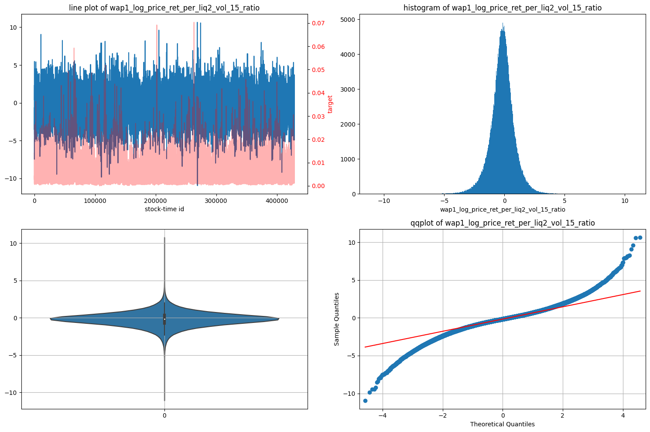

11. Wap1_log_price_ret_per_spread_sqr_vol_15_ratio:

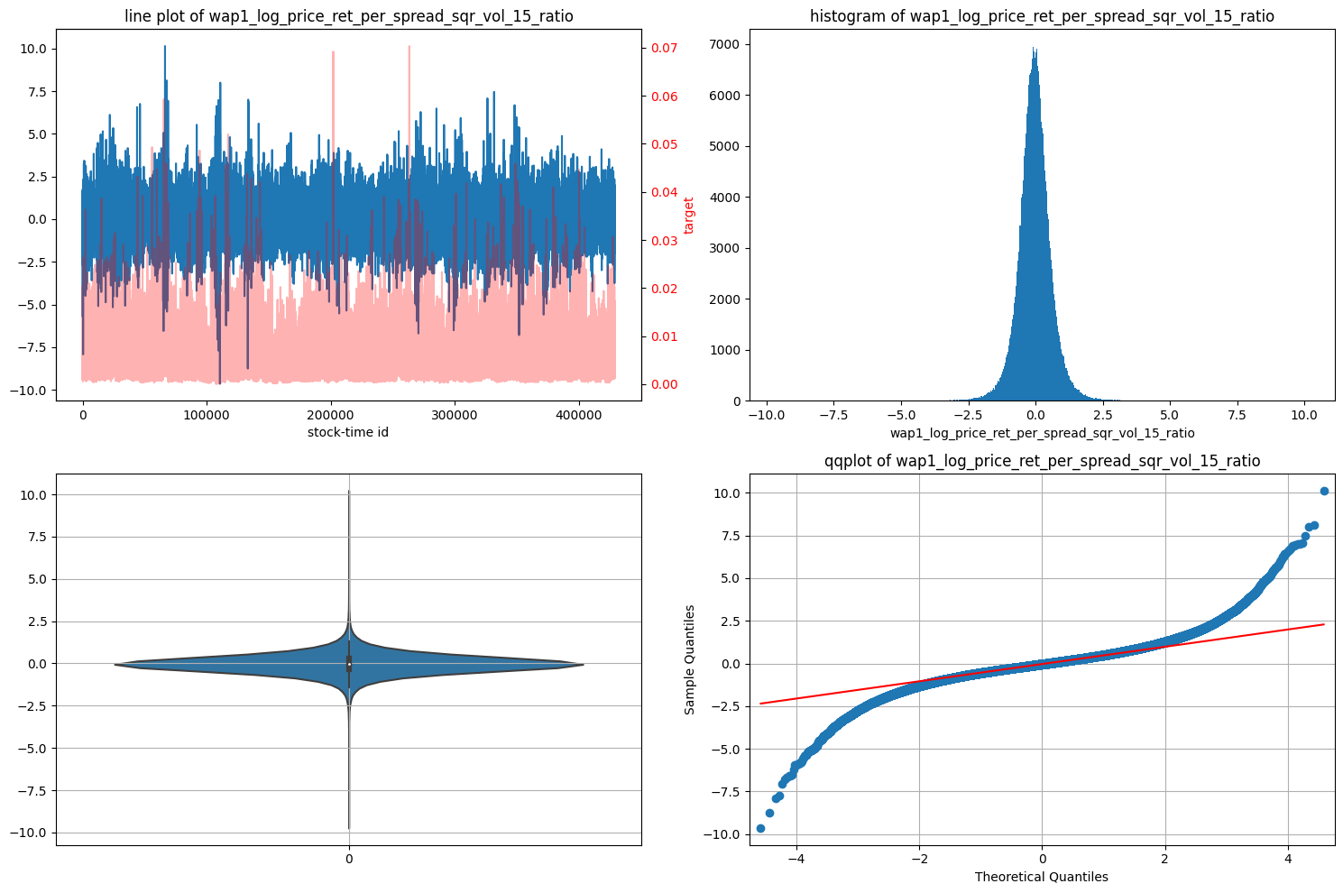

12. exp_log_liq1_ret_*_wap_eqi_price1_ret_vol_2_15_ratio

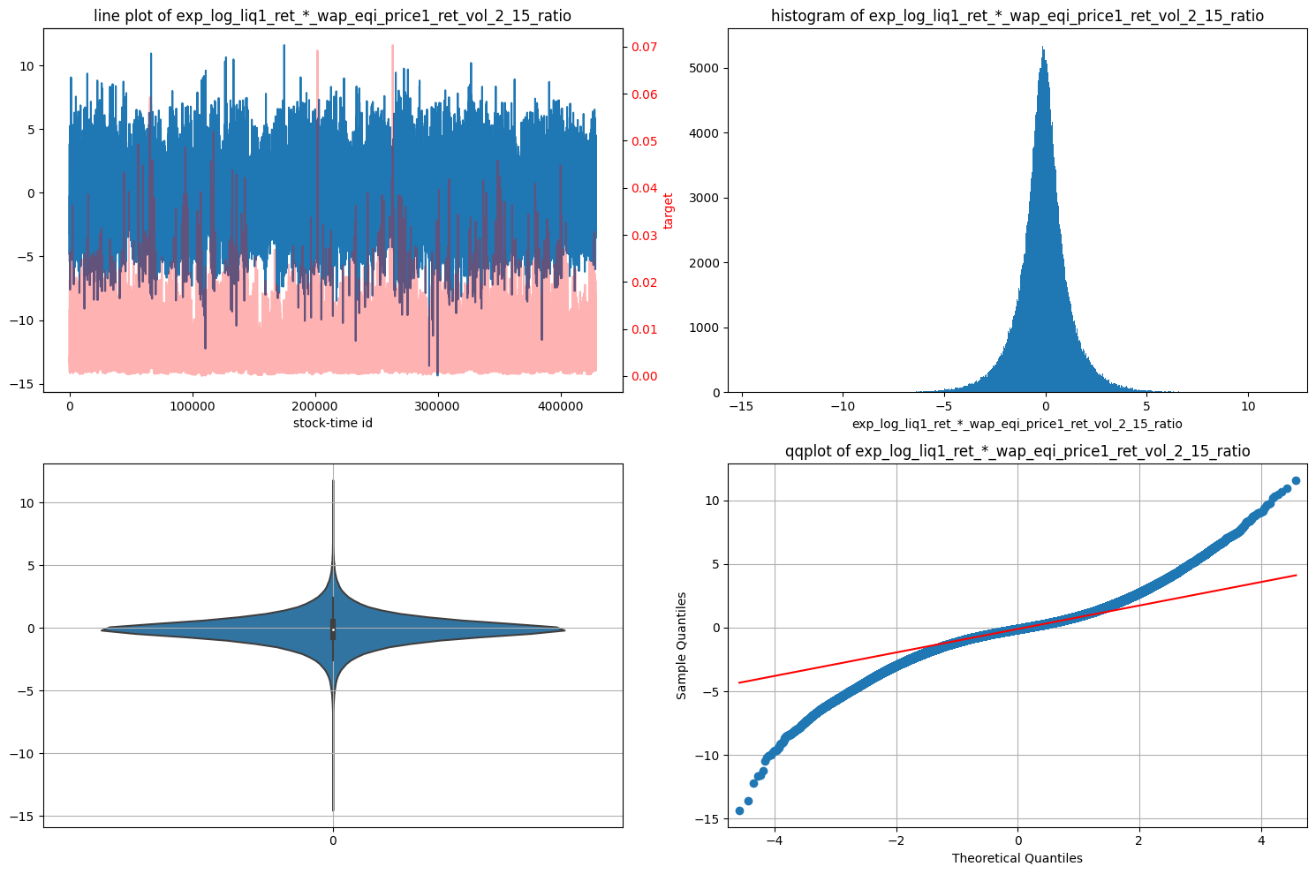

13.

1. V1proj_25_vvc2: v1 = volatility 1, proj means some ratio or subtraction type of comparison. 25 is time index. Vv = volume , c1 = cluster 1. Stocks clustered according to trade volume. WHat is the ratio of wap1_log_price_ret_vol_buks in last 25 bins to all bins. C2 has different number of trade volume clusters from c1.
2. V1proj_25_vvc3: similar to above. C3 has different number of trade volume clusters from c2 and c1.
3. V1spprojt15f25_c1: v1 = volatility 1, sp = spread , proj means some ratio or subtraction type of comparison. t15 is to time index. f25 is from time index, c1 = cluster 1. fraction of null values: 0.7365782921302211 num of null values: 315942

DISCARD

1. V1spprojt15f25_c2:Same as above, fraction of null values: 0.7249680602053472, num of null values: 310962 DISCARD
2. V1spprojt15f25_c3: fraction of null values: 0.7081821827236019, num of null values: 303762, num of inf values: 126, num of unique values: 4592, fraction of unique values: 0.010705659638357595 DISCARD
3. V1spprojt15f25_c4:fraction of null values: 0.688297912023351, num of null values: 295233, num of inf values: 85, num of unique values: 7323, fraction of unique values: 0.01707263622205851 DISCARD
4. V1spprojt15f25_vc1: fraction of null values: 0.7340650732517042 DISCARD
5. V1spprojt15f25_vc2: DISCARD
6. V1spprojt15f25_vc3: DISCARD
7. Tvpl2_rmed2v1: tvpl1 = trade volume per liquidity_wavg 2. rmed2v1= r, ratio of Med, median, 2, to v1, stocks overall wap1 return volatility1. Median along stock dimension.
8. Tvpl2_rmed2v1lf25: similar as above but using liquidity_wavg from bin 25 to 30 only.
9. Tvpl2_rmed2v1lf29: similar as above but using liquidity_wavg from bin 29 to 30 only.
10. Tvpl2: ratio of average of all buckets trade_volume to average of all buckets liquidity2. num of -inf values: 19

Removing the 19 negative inf values using x = x[x > -np.inf] solves the problem. Log (0) is causing -inf. This is ok because LGBM can handle -inf values.

1. Tvpl2_liqf10: num of -inf values: 19

Similar to above except liquidity_wavg starts from index 10 onwards.

1. Tvpl2_liqf20: num of -inf values: 19

Similar to above

1. Tvpl2_liqf29: num of -inf values: 19Similar to above
2. Tvpl2_smean_vol: ratio of average of all time ids and buckets trade_volume to average of all bucket liquidity2, shape of (3830,112,1). Tvpl2 = trade volume averaged over all buckets and time_ids (1,112,1) per liquidity2_wavg average across all buckets (3830,112,1). Smean_vol = stock’s mean volume. How liquidity at each time id compares with the full trade volume (at all time time ids) of every stock.

1. Tvpl2_smean_vol_liqf10: same as above but liquidity2_wavg starts from bin index 10
2. Tvpl2_smean_vol_liqf20: same as above but liquidity2_wavg starts from bin index 20
3. Tvpl2_smean_vol_liqf29: same as above but liquidity2_wavg starts from bin index 29
4. V1liq2projt5: To check the trend or see changes/ratio in liquidity2_wavg between first 5 bins vs last 2 bins from 28. NOt exactly sure why need to do **⅛??
5. V1liq2projt10: same as above but starts at liquidity2_wavg 10 divided by index 28: (last 2 bins)
6. V1liq2projt20: same as above starts at bin index 20divided by index 28: (last 2 bins)
7. Liqt10rf29: ratio of average of first 10 buckets liquidity2_wavg to average of last 1 buckets liquidity2, shape of (3830,112,1)
8. Liqt20rf29: ratio of average of first 20 buckets liquidity2_wavg to average of last 1 buckets liquidity2, shape of (3830,112,1)
9. V1liq2sprojt10f25: how liquidity2_wavg changes/ratio in first 10 bins to last 5 bins.

Very few outliers due to gap in qqplot. Bimodal distribution

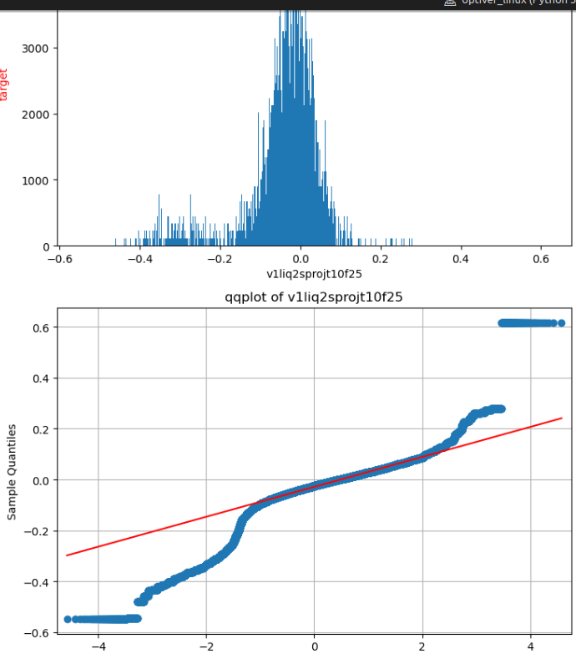

1. V1liq2sprojt5f25: similar to above but starting time bins is 5. Also a Bimodal distribution
2. V1spprojt10f29: median along stock id axis of ratio of mean of all buckets log_spread2_wavg to mean of last 1 bucket log_spread2_wavg , shape of (3830,1,1). starting time bins is 10. Also a Bimodal distribution
3. V1spprojt15f25: median along stock id axis of ratio of mean of first 15 buckets log_spread2_wavg to mean of last 5 bucket log_spread2_wavg , shape of (3830,1,1). Multimodal distribution

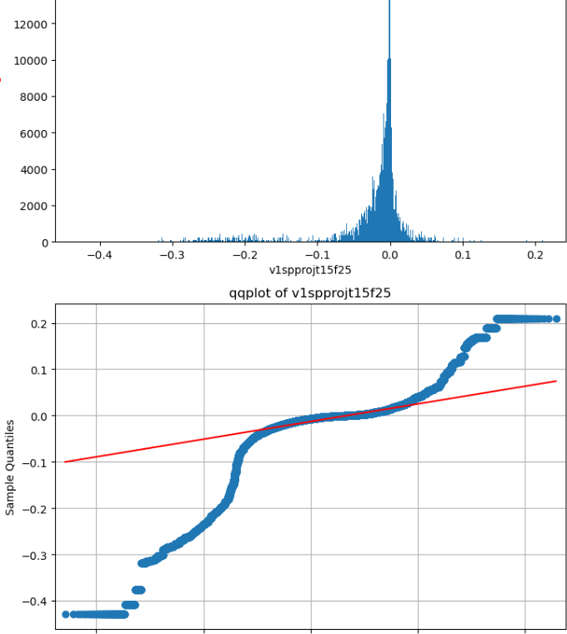

1. V1spprojt15f29: # median along stock id axis of ratio of mean of first 15 buckets log_spread2_wavg to mean of last 1 bucket log_spread2_wavg , shape of (3830,1,1). Similar to above.
2. V1spprojt15f29_q1: 25% quantile along stock id axis of ratio of mean of first 15 buckets log_spread2_wavg to mean of last 1 bucket log_spread2_wavg , shape of (3830,1,1). Multimodal.

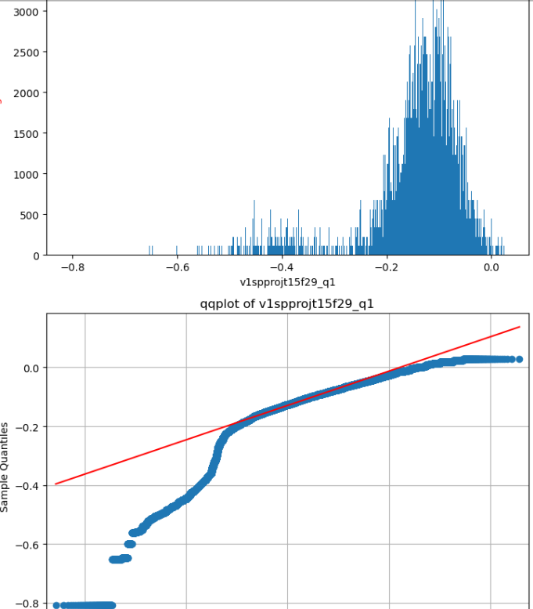

1. V1spprojt15f29_q3: # 75% quantile along stock id axis, of ratio of mean of first 15 buckets log_spread2_wavg to mean of last 1 bucket log_spread2_wavg , shape of (3830,1,1). Bimodal.
2. V1spprojt15f25_q1: similar to above. bimodal.
3. V1spprojt15f25_q3: similar to above. bimodal.

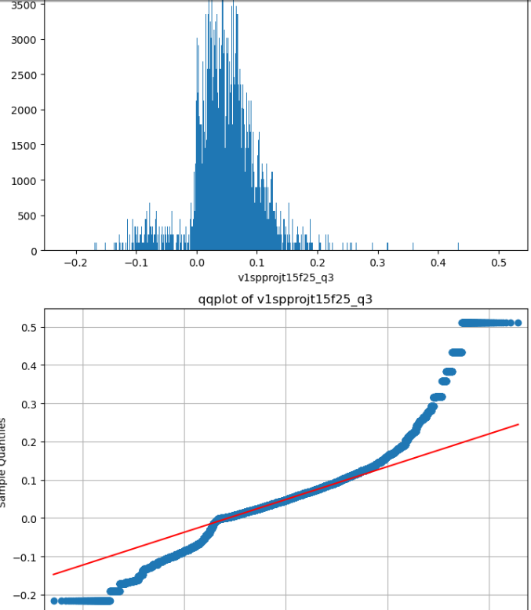

1. V1spprojtf29_q1: # 25% quantile along stock id axis,of ratio of mean of all buckets log_spread2_wavg to mean of last 1 bucket log_spread2_wavg , shape of (3830,1,1). BImodal.
2. V1spprojtf29_q3: # 75% quantile along stock id axis,of ratio of mean of all buckets log_spread2_wavg to mean of last 1 bucket log_spread2_wavg , shape of (3830,1,1). unimodal
3. V1spprojtf25_q1: # 25% quantile along stock id axis,of ratio of mean of all buckets log_spread2_wavg to mean of last 5 bucket log_spread2_wavg , shape of (3830,1,1).bimodal
4. V1spprojtf25_q3: # 75% quantile along stock id axis,of ratio of mean of all buckets log_spread2_wavg to mean of last 5 bucket log_spread2_wavg , shape of (3830,1,1). bimodal
5. Wap1_log_price_ret_vol_from_0: taking log of Wap1_log_price_ret_vol/Wap1_log_price_ret_vol which is log(1) so all are zero. DISCARD
6. Wap1_log_price_ret_volstock_mean_from_0: Mean across stock ids,

FORMULA = np.median( np.mean(wap1_log_price_ret_vol[:,:,ffrom:]/stocks_overall_wap1_log_price_ret_mean, 2, keepdims=True), 1, keepdims=True)

1. Wap1_log_price_ret_vol_from_10: similar to above
2. Wap1_log_price_ret_volstock_mean_from_10: similar to above
3. Wap1_log_price_ret_vol_from_20: similar to above
4. Wap1_log_price_ret_volstock_mean_from_20: similar to above
5. Wap1_log_price_ret_vol_from_25: similar to above num of inf values: 5
6. Wap1_log_price_ret_volstock_mean_from_25: similar to above
7. Vol1_mean: # standardize wap1_log_price_ret_vol by dividing by mean of wap1_log_price_ret_vol over all time periods for each stock.
8. Mean_half_delta: num of unique values: 112 (DISCARD)

fraction of unique values: 0.0002611136497160389

Very few Ourliers lie very far away from bulk of data.

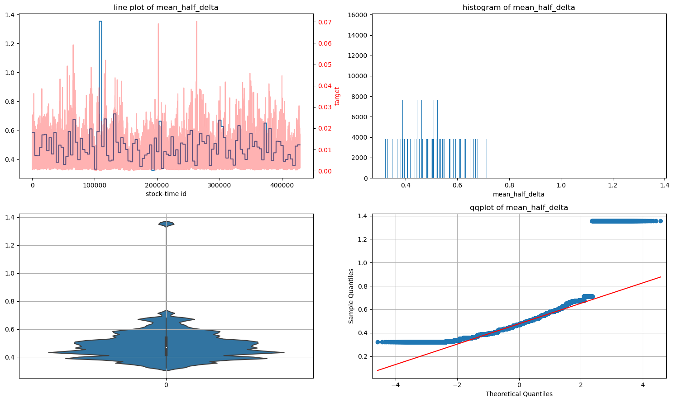

1. Mean_half_delta_lsprd: Similar to above, num of unique values: 112 (DISCARD)

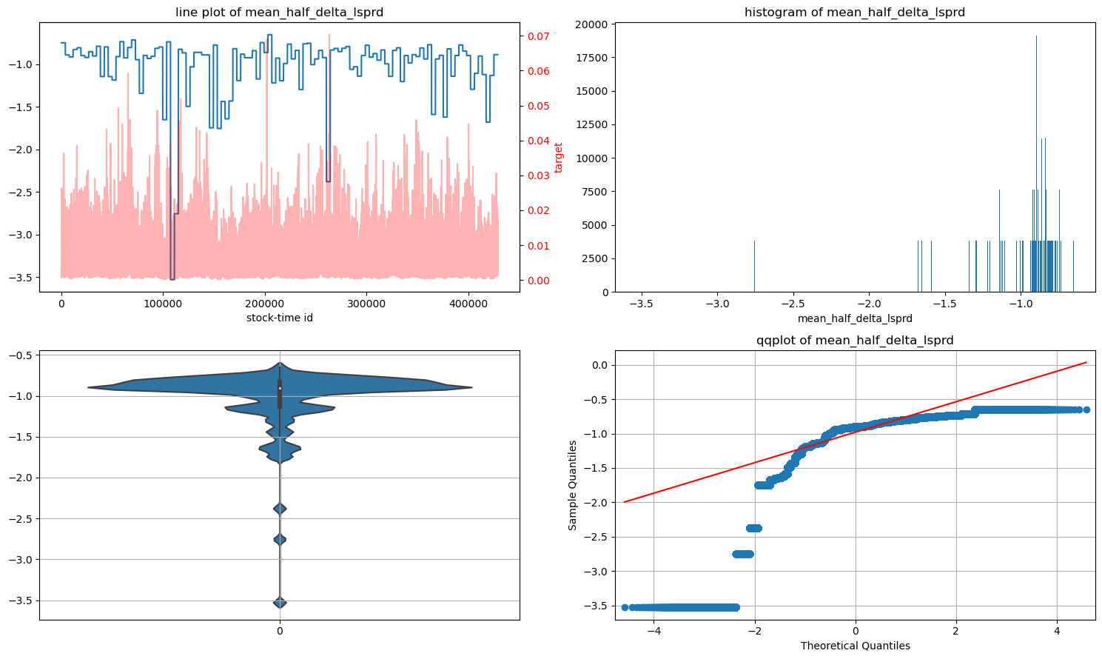

1. Log_wap1_log_price_ret_vol: log of volatility in wap1 log price returns.
2. Wap1_log_price_ret_cluster2_labels: CATEGORICAL feature.

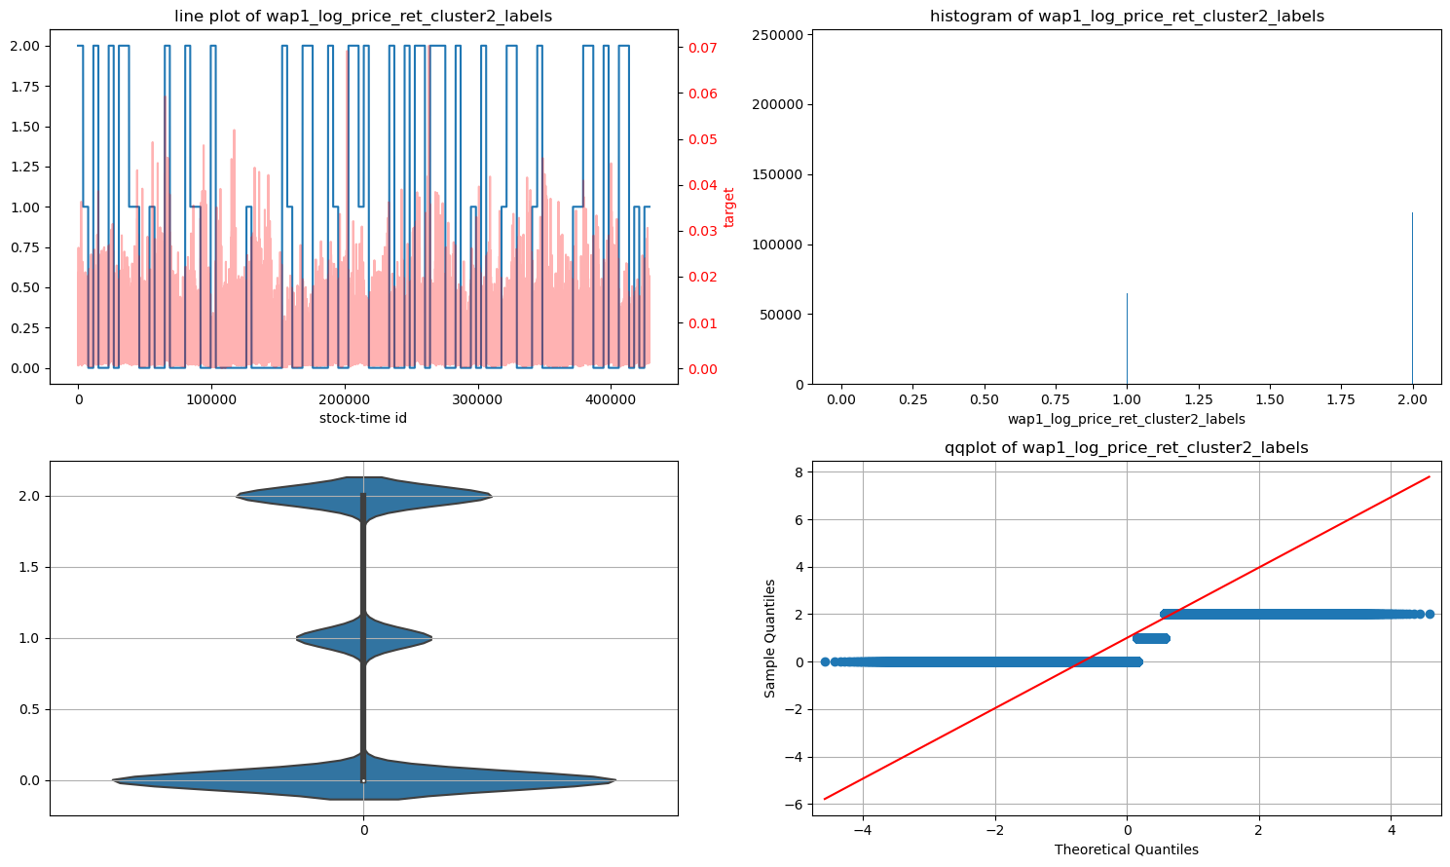

1. Wap1_log_price_ret_cluster3_labels: CATEGORICAL feature.

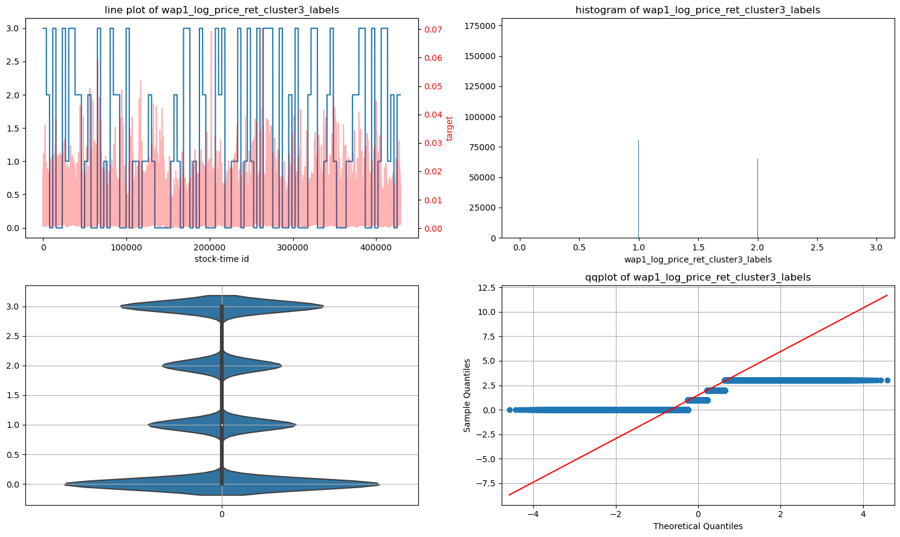

1. Target:
2. Log_target:
3. Log_target_standardized:
4. First_10_min_vol: first 10 min volatility calculated from wap1 price alone. Looks very similar to target. It can be log transformed in the future to look more normal from right skew. Log transform required. Yes done.
5. Trade_price_std: right skew.
6. Trade_price_real_vol: right skew,

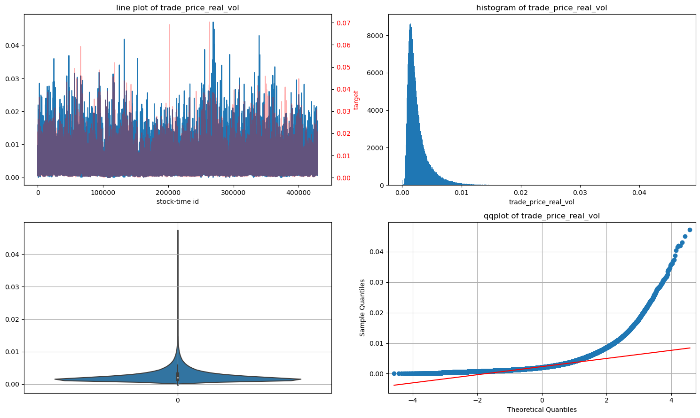

1. Trade_size_std: HIghly skewed with a heavy right tail. This has to be log1p transformed!!

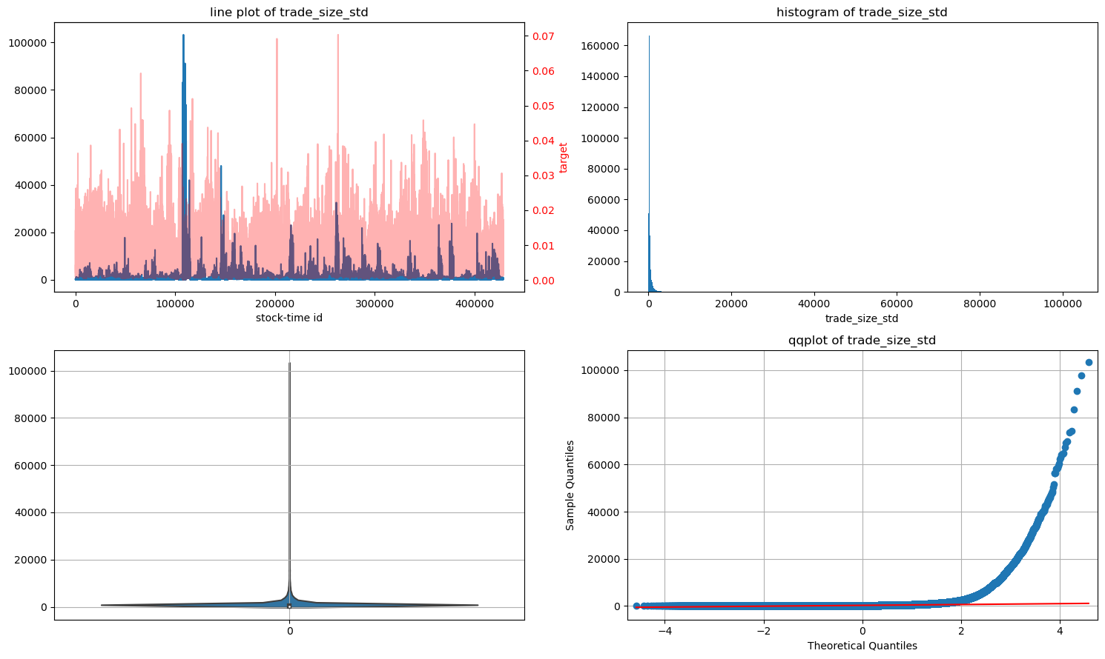

1. Trade_size_mean: similar case as aboveLog1p transform required.done
2. Trade_order_count_std: SIMilar ot above.Log1p transform required.done
3. Trade_order_count_mean: SIMilar ot above.Log1p transform required. done
4. Target_vol_sum_stats_4_clusters: similar to above. Log transform required. done
5. Target_vol_sum_stats_10_clusters: similar to above. Log transform required. done
6. Target_vol_sum_stats_16_clusters: similar to above. Log transform required. Done
7. Target_vol_sum_stats_30_clusters: similar to above. Log transform required. Done
8. Target_vol_corr_32_clusters: similar to above. Log transform required. Done
9. Target_vol_corr_4_clusters: similar to above. Log transform required. Done
10. Target_vol_corr_49_clusters: similar to above. Log transform required. Done
11. target_vol_corr_90_clusters : similar to above. Log transform required. Done
12. Min_bid_price1: no change ok.
13. Max_bid_price1: no change ok.
14. min_ask_price1: no change
15. Max_ask_price1: no change
16. Min_bid_size1: similar to above. Log transform required. Done

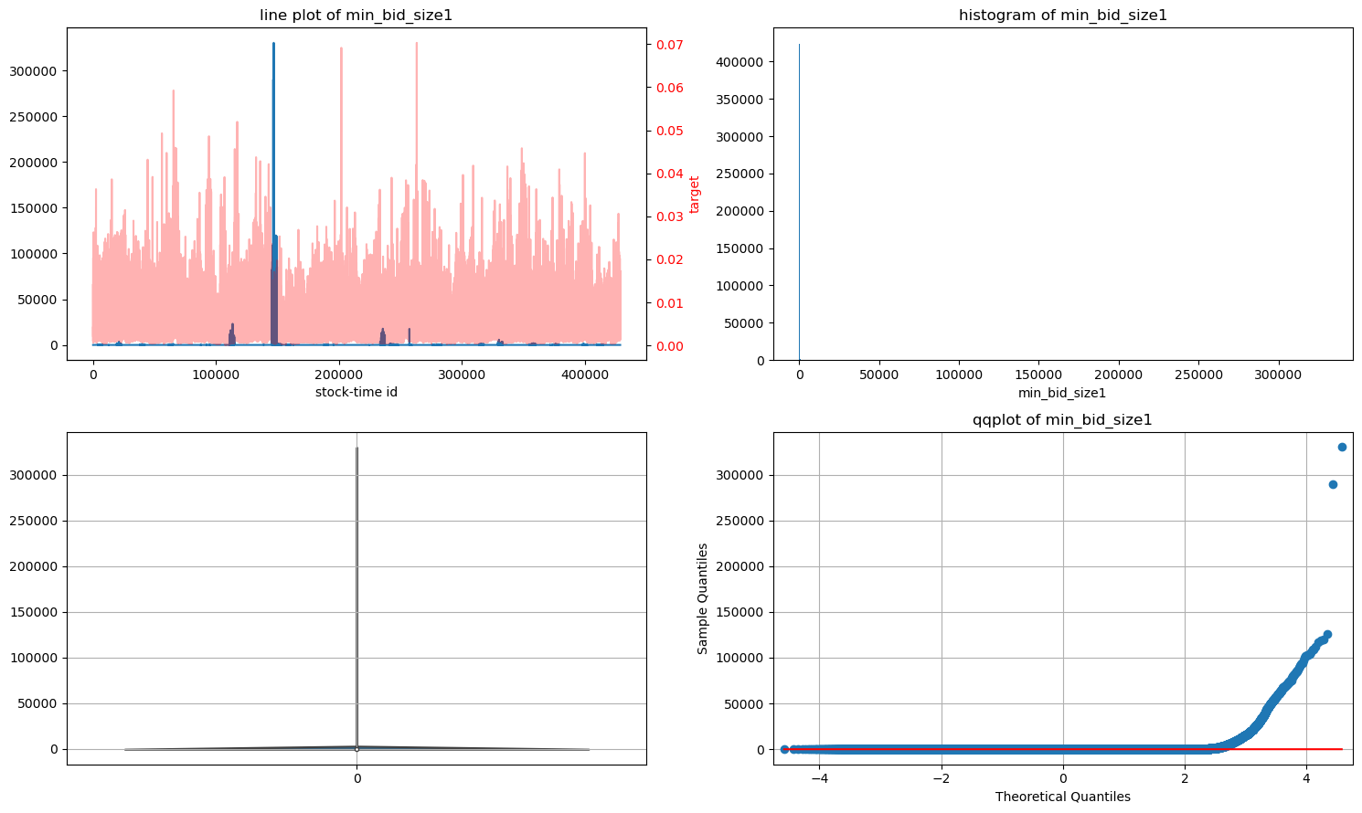

1. Max_bid_size1: similar to above. Log transform required. Done
2. Min_ask_size1: similar to above. Log transform required. Done
3. Max_ask_size1: similar to above. Log transform required. Done
4. Range_ask_price1:
5. Range_bid_price1:
6. Range_ask_size1: log1p applied
7. Range_bid_size1: log1p transformed, log1p_range_bid_size1_stnd
8. log_+1e-2_sad_ask_price1_stnd: ALL Null values
9. log1p_sad_ask_size1_stnd:
10. log_+1e-2_sad_bid_price1_stnd:
11. log1p_sad_bid_size1_stnd:
12. Bs_bp_corr1: exponential of left skew.
13. Bs_as_corr1: exponential of left skew.
14. Bs_ap_corr1: no change
15. Bp_as_corr1: no change
16. 3_bp_ap_corr1: subtracted 0.0001 and then took arctanh and then standardized . this is similar to fishers z transform.
17. As_ap_corr1:
18. Min_price1:
19. Max_price:
20. Min_price:
21. Max_price1:
22. Min_size1: log transform applied. Still highly skewed can be Discarded if needed
23. Max_size1: log transform applied. This is good.
24. Min_order_count1: highly SkewedDISCARD
25. Max_order_count1: LOG TRansfrom it.
26. Range_price1: fixed,
27. Range_size1: log1p transform.
28. Range_order_count1: log1p transform.
29. Sad_price1
30. Sad_size1: log1p transform
31. Sad_order_count1: log1p transform
32. Size_order_count_corr1:
33. Book_ewma_vol: log transform
34. Log1p_trade_ewma_vol_stnd:
35. Min_bid_price2:
36. Max_bid_price2
37. Min_ask_price2
38. Max_ask_price2:
39. Min_bid_size2: CAN be DISCARDED
40. Max_bid_size2: LOG Transform
41. Min_ask_size2: DISCARDED
42. Max_ask_size2: lop transform
43. Range_ask_price2:
44. Range_bid_price2:
45. Range_ask_size2: log transform
46. Sad_ask_size2: log transform
47. 'log_sad_ask_size2_stnd',
48. 'sad_bid_price2',
49. 'bs_bp_corr2',
50. 'bs_as_corr2',
51. 'bs_ap_corr2'
52. ‘Bp_as_corr2’
53. Bp_ap_corr2: subtracted 0.0001 and then took arctanh and then standardized . this is similar to fishers z transform.
54. As_ap_corr2:
55. Sum_stats_4_clusters_labels: categorical feature.
56. 'sum_stats_10_clusters_labels', : categorical feature.
57. 'sum_stats_16_clusters_labels',: categorical feature.
58. 'sum_stats_30_clusters_labels', : categorical feature.
59. 'pear_corr_32_clusters_labels',: categorical feature.
60. 'Pear_corr_4_clusters_labels',: categorical feature.
61. 'pear_corr_49_clusters_labels',: categorical feature.
62. 'pear_corr_90_clusters_labels': categorical feature.

* **Identify if any columns still have null and infinity values**

**NUmber of Null values**

wap2_logprice_ret_changes_n_wap1_logprice_ret_constant_sqr_vol_15_ratio : 589

wap2_logprice_ret_changes_n_wap1_logprice_ret_constant_sqr_vol_15_ratio_median_stock : 54086

trade_count_15_15 : 19

root_trade_count_15_15 : 19

v1proj_25_15_std : 560

v1proj_29_15_std : 282002  **Discard**

v1proj_25_std : 560

v1proj_29_std : 51517

v1proj_25_c1_std : 325

v1proj_25_c2_std : 284

v1proj_25_c3_std : 177

v1proj_25_c4_std : 112

v1proj_25_c5_std : 89

v1spprojt15f25_c1 : 315942 **Discard**

v1spprojt15f25_c2 : 310962 **Discard**

v1spprojt15f25_c3 : 303762 **Discard**

v1spprojt15f25_c4 : 295233 **Discard**

v1spprojt15f25_vc1 : 314864 **Discard**

v1spprojt15f25_vc2 : 310913 **Discard**

v1spprojt15f25_vc3 : 298756 **Discard**

log_log_log_max_ask_size1_stnd_stnd_stnd : 29575

**NUmber of Inf values**

wap1_log_price_ret_per_liq2_vol_15_ratio : 1

wap1_log_price_ret_per_spread_sqr_vol_15_ratio : 1

wap2_logprice_ret_changes_n_wap1_logprice_ret_constant_sqr_vol_15_ratio : 2831

wap2_logprice_ret_changes_n_wap1_logprice_ret_constant_sqr_vol : 589

lsvol : 139

trade_count : 19

root_trade_count : 19

root_trade_count_var : 19

trade_count_15_15 : 397

root_trade_count_15_15 : 397

v1spprojt15f25_c3 : 126

v1spprojt15f25_c4 : 85

v1spprojt15f25_vc1 : 63

v1spprojt15f25_vc2 : 153

v1spprojt15f25_vc3 : 133

tvpl2 : 19

tvpl2_liqf10 : 19

tvpl2_liqf20 : 19

tvpl2_liqf29 : 19

wap1_log_price_ret_vol_from_25 : 5

**All feature with excess NAN / NULL values and other useless features are discarded**

**Final features after initial elimination**

**Shape : (428932, 222)**

1. stock_id
2. time_id
3. wap1_log_price_ret_vol
4. log_liq2_ret_*_wap_eqi_price1_ret_vol
5. exp_log_liq1_ret_*_wap_eqi_price1_ret_vol
6. exp_log_liq1_ret_*_wap_eqi_price1_ret_vol_2
7. wap1_log_price_ret_per_liq2_vol
8. wap1_log_price_ret_per_spread_sqr_vol
9. log_liq2_ret_*_wap_eqi_price1_ret_vol_15_ratio
10. wap1_log_price_ret_per_liq2_vol_15_ratio
11. wap1_log_price_ret_per_spread_sqr_vol_15_ratio
12. exp_log_liq1_ret_*_wap_eqi_price1_ret_vol_15_ratio
13. exp_log_liq1_ret_*_wap_eqi_price1_ret_vol_2_15_ratio
14. wap2_logprice_ret_changes_n_wap1_logprice_ret_constant_sqr_vol_15_ratio
15. wap2_logprice_ret_changes_n_wap1_logprice_ret_constant_sqr_vol_15_ratio_median_stock
16. log_liq2_ret_*_wap_eqi_price1_ret_vol_15_ratio_median_stock
17. wap1_log_price_ret_per_spread_sqr_vol_15_ratio_median_stock
18. wap2_logprice_ret_changes_n_wap1_logprice_ret_constant_sqr_vol
19. wap1_log_price_ret_neg_log_liq_ret_sqr_vol
20. wap1_log_price_ret_pos_log_liq_ret_sqr_vol
21. wap1_log_price_ret_pos-neg_log_liq_ret_sqr_vol
22. wap1_lprice_ret_vol_ati_*_wap1_lprice_ret_vol_ast_per_wap1_lprice_ret_vol_:0
23. wap1_lprice_ret_vol_ati_*_wap1_lprice_ret_avg_ast_per_wap1_lprice_ret_vol_:0
24. wap1_log_price_ret_normalized*mean_centered_per_wap1_lprice_ret_vol_:0
25. wap1_lprice_ret_vol_ati_*_wap1_lprice_ret_vol_ast_per_wap1_lprice_ret_vol_:10
26. wap1_lprice_ret_vol_ati_*_wap1_lprice_ret_avg_ast_per_wap1_lprice_ret_vol_:10
27. wap1_log_price_ret_normalized*mean_centered_per_wap1_lprice_ret_vol_:10
28. wap1_lprice_ret_vol_ati_*_wap1_lprice_ret_vol_ast_per_wap1_lprice_ret_vol_:20
29. wap1_lprice_ret_vol_ati_*_wap1_lprice_ret_avg_ast_per_wap1_lprice_ret_vol_:20
30. wap1_log_price_ret_normalized*mean_centered_per_wap1_lprice_ret_vol_:20
31. soft_stock_mean_tvpl2_:0
32. soft_stock_mean_tvpl2_:10
33. soft_stock_mean_tvpl2_:20
34. soft_stock_mean_tvpl2_liqf
35. soft_stock_mean_tvpl2_liqf_volf10
36. soft_stock_mean_tvpl2_liqf_volf20
37. v1proj_25_15
38. v1proj_25_15_lr1_high_corr_stocks
39. v1proj_25_15_vol1_high_corr_stocks
40. v1proj_25_lr1_high_corr_stocks
41. v1proj_25_vol1_high_corr_stocks
42. lsvol
43. liqvol1
44. liqvol1_smean
45. liqvol1_smean_c3
46. liqvol2
47. liqvol1_15_15
48. trade_count
49. root_trade_count
50. root_trade_count_smean
51. root_book_delta_count
52. root_trade_count_smean_c1
53. root_trade_count_smean_c2
54. root_trade_count_smean_c3
55. root_trade_count_var
56. trade_count_15_15
57. root_trade_count_15_15
58. v1proj_29_15
59. v1proj_20
60. v1proj_25
61. v1proj_29
62. v1proj_29_q1
63. v1proj_29_q3
64. v1proj_25_q1
65. v1proj_25_q3
66. v1proj_29_15_q1
67. v1proj_29_15_q3
68. v1proj_25_15_q1
69. v1proj_25_15_q3
70. v1proj_25_15_std
71. v1proj_20_std
72. v1proj_25_std
73. v1proj_29_std
74. v1proj_29_q3q1
75. v1proj_25_c1
76. v1proj_25_c2
77. v1proj_25_c3
78. v1proj_25_c4
79. v1proj_25_c5
80. soft_stock_mean_tvpl2_c1
81. soft_stock_mean_tvpl2_c2
82. soft_stock_mean_tvpl2_c3
83. soft_stock_mean_tvpl2_10_c1
84. soft_stock_mean_tvpl2_10_c2
85. soft_stock_mean_tvpl2_10_c3
86. soft_stock_mean_tvpl2_20_c1
87. soft_stock_mean_tvpl2_20_c2
88. soft_stock_mean_tvpl2_20_c3
89. v1proj_25_c1_std
90. v1proj_25_c2_std
91. v1proj_25_c3_std
92. v1proj_25_c4_std
93. v1proj_25_c5_std
94. v1proj_25_vc1
95. v1proj_25_vc2
96. v1proj_25_vc3
97. v1proj_25_vc4
98. v1proj_25_vvc1
99. v1proj_25_vvc2
100. v1proj_25_vvc3
101. tvpl2_rmed2v1
102. tvpl2_rmed2v1lf25
103. tvpl2_rmed2v1lf29
104. tvpl2
105. tvpl2_liqf10
106. tvpl2_liqf20
107. tvpl2_liqf29
108. tvpl2_smean_vol
109. tvpl2_smean_vol_liqf10
110. tvpl2_smean_vol_liqf20
111. tvpl2_smean_vol_liqf29
112. v1liq2projt5
113. v1liq2projt10
114. v1liq2projt20
115. liqt10rf29
116. liqt20rf29
117. v1liq2sprojt10f25
118. v1liq2sprojt5f25
119. v1spprojt10f29
120. v1spprojt15f25
121. v1spprojt15f29
122. v1spprojt15f29_q1
123. v1spprojt15f29_q3
124. v1spprojt15f25_q1
125. v1spprojt15f25_q3
126. v1spprojtf29_q1
127. v1spprojtf29_q3
128. v1spprojtf25_q1
129. v1spprojtf25_q3
130. wap1_log_price_ret_volstock_mean_from_0
131. wap1_log_price_ret_vol_from_10
132. wap1_log_price_ret_volstock_mean_from_10
133. wap1_log_price_ret_vol_from_20
134. wap1_log_price_ret_volstock_mean_from_20
135. wap1_log_price_ret_vol_from_25
136. wap1_log_price_ret_volstock_mean_from_25
137. vol1_mean
138. log_wap1_log_price_ret_vol
139. wap1_log_price_ret_cluster2_labels
140. wap1_log_price_ret_cluster3_labels
141. target
142. log_target
143. log_target_standardized
144. log_first_10_min_vol_stnd
145. trade_price_std
146. trade_price_real_vol
147. log1p_log_1ptrade_size_std_stnd_stnd
148. log1p_trade_size_mean_stnd
149. log1p_trade_order_count_std_stnd
150. log1p_trade_order_count_mean_stnd
151. log_target_vol_sum_stats_4_clusters_stnd
152. log_target_vol_sum_stats_10_clusters_stnd
153. log_target_vol_sum_stats_16_clusters_stnd
154. log_target_vol_sum_stats_30_clusters_stnd
155. log_target_vol_corr_32_clusters_stnd
156. log_target_vol_corr_4_clusters_stnd
157. log_target_vol_corr_49_clusters_stnd
158. log_target_vol_corr_90_clusters_stnd
159. min_bid_price1
160. max_bid_price1
161. min_ask_price1
162. max_ask_price1
163. log_min_bid_size1_stnd
164. log_max_bid_size1_stnd
165. log_min_ask_size1_stnd
166. log_log_log_max_ask_size1_stnd_stnd_stnd
167. range_ask_price1
168. range_bid_price1
169. log1p_range_ask_size1_stnd
170. log1p_range_bid_size1_stnd
171. log_+1e-2_sad_ask_price1_stnd
172. log1p_sad_ask_size1_stnd
173. log_+1e-2_sad_bid_price1_stnd
174. log1p_sad_bid_size1_stnd
175. exp_bs_bp_corr1_stnd
176. exp_bs_as_corr1_stnd
177. bs_ap_corr1
178. bp_as_corr1
179. arctanh_min_1e-3_bp_ap_corr1_stnd
180. as_ap_corr1
181. min_price1
182. max_price
183. min_price
184. max_price1
185. log_min_size1_stnd
186. log_max_size1_stnd
187. log_max_order_count1_stnd
188. log_+1e-3_range_price1_stnd
189. log1p_range_size1_stnd
190. log1p_range_order_count1_stnd
191. sad_price1
192. log1p_sad_size1_stnd
193. log1p_sad_order_count1_stnd
194. size_order_count_corr1
195. log_book_ewma_vol_stnd
196. log1p_trade_ewma_vol_stnd
197. min_bid_price2
198. max_bid_price2
199. min_ask_price2
200. max_ask_price2
201. log_max_bid_size2_stnd
202. log_max_ask_size2_stnd
203. range_ask_price2
204. range_bid_price2
205. log_range_ask_size2_stnd
206. sad_ask_price2
207. log_sad_ask_size2_stnd
208. sad_bid_price2
209. bs_bp_corr2
210. bs_as_corr2
211. bs_ap_corr2
212. bp_as_corr2
213. arctanh_min_1e-3_bp_ap_corr2_stnd
214. as_ap_corr2
215. sum_stats_4_clusters_labels
216. sum_stats_10_clusters_labels
217. sum_stats_16_clusters_labels
218. sum_stats_30_clusters_labels
219. pear_corr_32_clusters_labels
220. pear_corr_4_clusters_labels
221. pear_corr_49_clusters_labels
222. pear_corr_90_clusters_labels

Change of naming convention for LGBM model because removing special characters like “+”, “*” and “:” and replacing with blank

FROM:

########### numerical features

## float32 features

'log_+1e-2_sad_ask_price1_stnd',

'log_+1e-2_sad_bid_price1_stnd',

'log_+1e-3_sad_price1_stnd',

'log_+1e-3_sad_ask_price2_stnd',

'log_+1e-3_sad_bid_price2_stnd',]

## float64 features

'log_liq2_ret_*_wap_eqi_price1_ret_vol',

'exp_log_liq1_ret_*_wap_eqi_price1_ret_vol',

'log_liq2_ret_*_wap_eqi_price1_ret_vol_15_ratio',

'exp_log_liq1_ret_*_wap_eqi_price1_ret_vol_15_ratio',

'log_liq2_ret_*_wap_eqi_price1_ret_vol_15_ratio_median_stock',

'wap1_lprice_ret_vol_ati_*_wap1_lprice_ret_vol_ast_per_wap1_lprice_ret_vol_:0',

'wap1_lprice_ret_vol_ati_*_wap1_lprice_ret_avg_ast_per_wap1_lprice_ret_vol_:0',

'wap1_log_price_ret_normalized*mean_centered_per_wap1_lprice_ret_vol_:0',

'wap1_lprice_ret_vol_ati_*_wap1_lprice_ret_vol_ast_per_wap1_lprice_ret_vol_:10',

'wap1_lprice_ret_vol_ati_*_wap1_lprice_ret_avg_ast_per_wap1_lprice_ret_vol_:10',

'wap1_log_price_ret_normalized*mean_centered_per_wap1_lprice_ret_vol_:10',

'wap1_lprice_ret_vol_ati_*_wap1_lprice_ret_vol_ast_per_wap1_lprice_ret_vol_:20',

'wap1_lprice_ret_vol_ati_*_wap1_lprice_ret_avg_ast_per_wap1_lprice_ret_vol_:20',

'wap1_log_price_ret_normalized*mean_centered_per_wap1_lprice_ret_vol_:20',

'soft_stock_mean_tvpl2_:0',

'soft_stock_mean_tvpl2_:10',

'Soft_stock_mean_tvpl2_:20',

'log_+1e-3_range_price1_stnd',

'log_+1e-3_range_ask_price2_stnd',

'Log_+1e-3_range_bid_price2_stnd',

'log_wap1_lprice_ret_vol_ati_*_wap1_lprice_ret_vol_ast_per_wap1_lprice_ret_vol_:0_stnd',

'log_wap1_lprice_ret_vol_ati_*_wap1_lprice_ret_avg_ast_per_wap1_lprice_ret_vol_:0_stnd',

'log_wap1_lprice_ret_vol_ati_*_wap1_lprice_ret_vol_ast_per_wap1_lprice_ret_vol_:10_stnd',

'log_wap1_lprice_ret_vol_ati_*_wap1_lprice_ret_avg_ast_per_wap1_lprice_ret_vol_:10_stnd',

'log_wap1_lprice_ret_vol_ati_*_wap1_lprice_ret_vol_ast_per_wap1_lprice_ret_vol_:20_stnd',

'log_wap1_lprice_ret_vol_ati_*_wap1_lprice_ret_avg_ast_per_wap1_lprice_ret_vol_:20_stnd']

**TSFresh features after ordering the time ids:**

Now the stock’s price/size are a time series.

**Original time series from which tsfresh features can be extracted:**

1. Historical realized volatiltiy of each stock.
2. Overall average market (all the given 112 stocks historic realised) volatility
3. LIquidity features (select a few) of each stock
4. Correlation between stock and overall market
5. ~~Historical target~~

**Feature SELECTION**

**Variance thresholding**

After MIN-MAX scaling, variance of features:

count 207.000000 (< 222, because of nan values)

mean 0.012473

std 0.023148

min 0.000133

25% 0.003158

50% 0.006795

75% 0.010838

max 0.192898

**The features with smallest variances at different percentiles:**

percentile: 0.1 %, threshold: 0.00013401160515899243

Index(['wap1_lprice_ret_vol_ati_*_wap1_lprice_ret_vol_ast_per_wap1_lprice_ret_vol_:0']

percentile: 1 %, threshold: 0.00016768059901351947

Index(['wap1_lprice_ret_vol_ati_*_wap1_lprice_ret_vol_ast_per_wap1_lprice_ret_vol_:0',

'wap1_lprice_ret_vol_ati_*_wap1_lprice_ret_vol_ast_per_wap1_lprice_ret_vol_:10',

'wap1_lprice_ret_vol_ati_*_wap1_lprice_ret_vol_ast_per_wap1_lprice_ret_vol_:20']

percentile: 5 %, threshold: 0.00046704710681564406

Index(['wap1_lprice_ret_vol_ati_*_wap1_lprice_ret_vol_ast_per_wap1_lprice_ret_vol_:0',

'wap1_lprice_ret_vol_ati_*_wap1_lprice_ret_avg_ast_per_wap1_lprice_ret_vol_:0',

'wap1_lprice_ret_vol_ati_*_wap1_lprice_ret_vol_ast_per_wap1_lprice_ret_vol_:10',

'wap1_lprice_ret_vol_ati_*_wap1_lprice_ret_avg_ast_per_wap1_lprice_ret_vol_:10',

'wap1_lprice_ret_vol_ati_*_wap1_lprice_ret_vol_ast_per_wap1_lprice_ret_vol_:20',

'wap1_lprice_ret_vol_ati_*_wap1_lprice_ret_avg_ast_per_wap1_lprice_ret_vol_:20',

'v1proj_25_vvc2', 'max_bid_price1', 'max_price', 'max_price1',

'max_bid_price2']

percentile: 10 %, threshold: 0.0006770786381448333

Index(['wap1_lprice_ret_vol_ati_*_wap1_lprice_ret_vol_ast_per_wap1_lprice_ret_vol_:0',

'wap1_lprice_ret_vol_ati_*_wap1_lprice_ret_avg_ast_per_wap1_lprice_ret_vol_:0',

'wap1_lprice_ret_vol_ati_*_wap1_lprice_ret_vol_ast_per_wap1_lprice_ret_vol_:10',

'wap1_lprice_ret_vol_ati_*_wap1_lprice_ret_avg_ast_per_wap1_lprice_ret_vol_:10',

'wap1_lprice_ret_vol_ati_*_wap1_lprice_ret_vol_ast_per_wap1_lprice_ret_vol_:20',

'wap1_lprice_ret_vol_ati_*_wap1_lprice_ret_avg_ast_per_wap1_lprice_ret_vol_:20',

'v1proj_25_vvc2', 'v1proj_25_vvc3', 'wap1_log_price_ret_vol_from_10',

'min_bid_price1', 'max_bid_price1', 'min_ask_price1', 'max_ask_price1',

'min_price1', 'max_price', 'min_price', 'max_price1', 'min_bid_price2',

'max_bid_price2', 'min_ask_price2', 'max_ask_price2']

In case of overfitting or poor model performance some of these features can be eliminated.

**Correlation analysis between features and target**

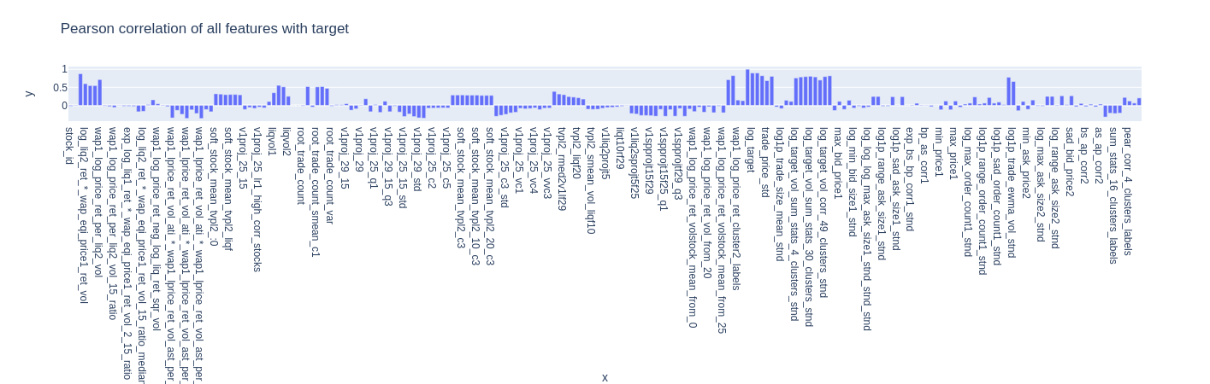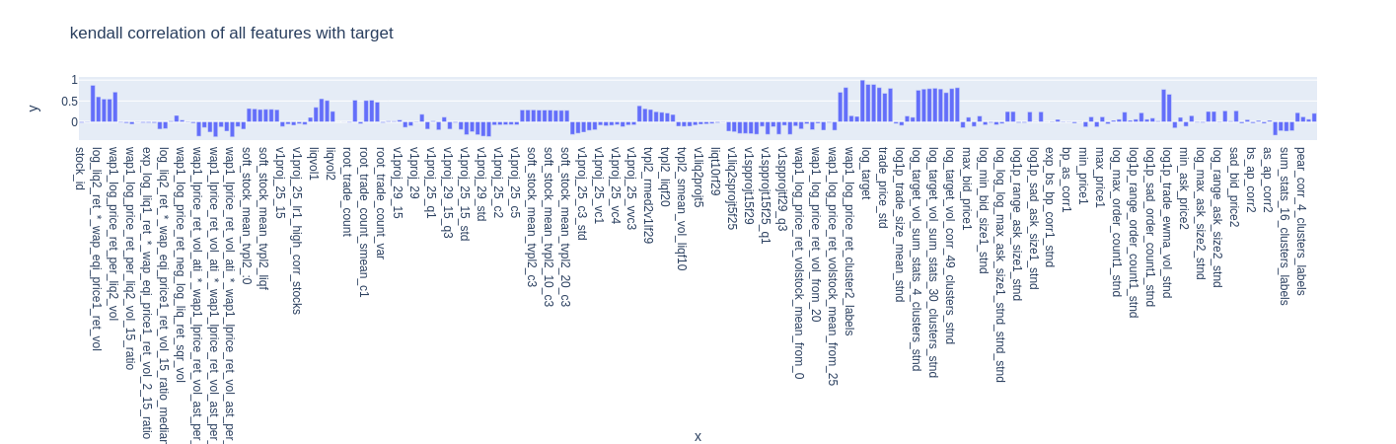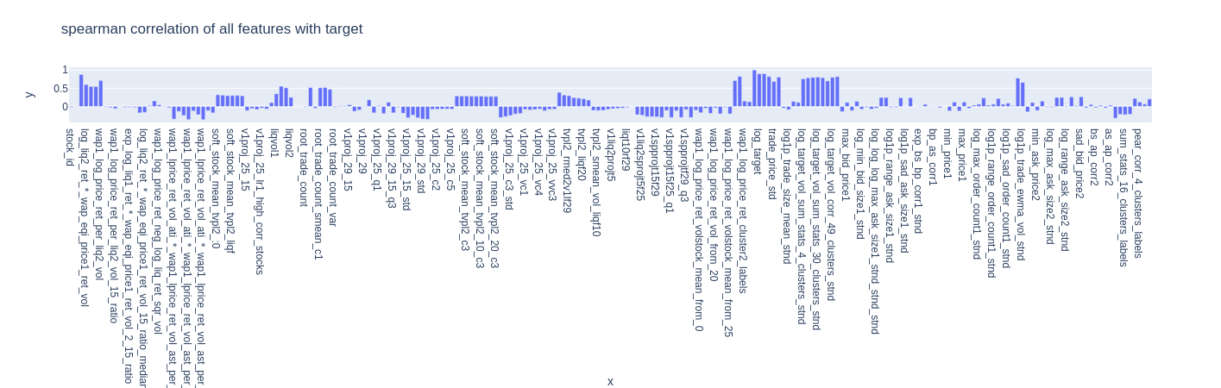

28) how to encode time order information (ordinal categorical feature) in train-test tabular dataset for lgbm? How does model know that t=0 sample occurred before t=1?

* Include sequence_id to represent number from 1 - 3830
* Make this categorical variable explicit

29) we want to include periodicity information about the time series?

* 9 time_ids represent 1 day.
* 21 trading days in a month, 21*9 = 189 time_ids
* Make this categorical variable explicit

**Hand picking features to understand the lgbm model the feature’s impact**

1. **ONLY using first level wap and without any ratios**

SELECTED FEATURES:

time_id

stock_id

log_liq2_ret__wap_eqi_price1_ret_vol

exp_log_liq1_ret__wap_eqi_price1_ret_vol

wap1_log_price_ret_per_liq2_vol

wap1_log_price_ret_per_spread_sqr_vol

wap1_log_price_ret_neg_log_liq_ret_sqr_vol

wap1_log_price_ret_pos_log_liq_ret_sqr_vol

wap1_log_price_ret_posneg_log_liq_ret_sqr_vol

soft_stock_mean_tvpl2_liqf

lsvol

liqvol1

trade_count

root_book_delta_count

tvpl2

log_wap1_log_price_ret_vol

log_first_10_min_vol_stnd

log_1e3_trade_price_real_vol_stnd

log1p_trade_order_count_std_stnd

log1p_trade_order_count_mean_stnd

log_target_vol_corr_32_clusters_stnd

log_target_vol_sum_stats_16_clusters_stnd

max_bid_price1

max_ask_price1

log_max_bid_size1_stnd

log_1e3_range_bid_price1_stnd

log1p_range_ask_size1_stnd

log1p_sad_ask_size1_stnd

log_1e2_sad_bid_price1_stnd

exp_bs_as_corr1_stnd

bs_ap_corr1

max_price1

log_max_size1_stnd

log1p_range_order_count1_stnd

log_1e3_sad_price1_stnd

log1p_sad_size1_stnd

size_order_count_corr1

log_book_ewma_vol_stnd

log1p_trade_ewma_vol_stnd

max_bid_price2

max_ask_price2

log_max_bid_size2_stnd

log_1e3_range_ask_price2_stnd

log_range_ask_size2_stnd

log_1e3_sad_bid_price2_stnd

bs_bp_corr2

bs_ap_corr2

as_ap_corr2

sum_stats_4_clusters_labels

sum_stats_10_clusters_labels

sum_stats_16_clusters_labels

sum_stats_30_clusters_labels

pear_corr_32_clusters_labels

pear_corr_4_clusters_labels

pear_corr_49_clusters_labels

pear_corr_90_clusters_labels

exp_root_trade_count_var_stnd

seq_id

per9_id

per45_id

per189_id

target

**Plot each stock real. vol. prediction separately instead of contiguously.**

To understand what is happening in each stock. To identify the badly predicted stocks.

**Ensemble Models based on LGBM**

1. GBRT
2. DART
3. Decision Trees
4. GJR-GARCH
5. Tabnet
6. SoftOrdering1DCNN

<https://machinelearningmastery.com/information-gain-and-mutual-information/>